GRAFFINITI: AUGMENTED REALITY BASED DIGITAL GRAFFITI PLATFORM

Haider Ahmad Ashraf
Sharoon Shaleem
Raja Muhammad Zubair

Supervised By
Dr. Sadia Ashraf

Submitted for the partial fulfillment of BS Computer Science degree to the Faculty of Engineering & Computing
NATIONAL UNIVERSITY OF MODERN LANGUAGES ISLAMABAD DECEMBER, 2025

ABSTRACT
Graffiniti is a mobile app that brings the bold, creative spirit of graffiti into the digital world through Augmented Reality (AR). While traditional graffiti is often limited by legal and social restrictions, Graffiniti offers a safe and legal way to express creativity in public spaces-without the physical paint.
Currently, most digital art platforms don't capture the unique, location-based nature of graffiti. This gap inspired the development of Graffiniti, an AR-powered app built with Flutter that allows users to create and view virtual graffiti in real-world locations using their smartphone cameras.
The app includes modules for graffiti creation (with tools like sprays, brushes, text, and stickers), GPS-based location tagging, content storage via Firebase Firestore, and user authentication using Firebase Authentication. It also features map-based discovery, community interaction tools (like groups, likes, and challenges), and customizable user profiles.
By using ARCore for realistic graffiti placement and a modular development approach, Graffiniti ensures a smooth and scalable experience. Initial testing will focus on Android.
In the future, Graffiniti aims to grow into a vibrant, cross-platform community that blends art, technology, and public spaces-empowering users to share their voices in a whole new way.
Keywords: Augmented Reality, Digital Graffiti, Location-based art, Social Art Platform

CERTIFICATE

Dated: _____________

Final Approval

It is certified that the project report titled ‘GRAFFINITI: AUGMENTED REALITY BASED DIGITAL GRAFFITI PLATFORM’ submitted by Haider Ahmad Ashraf, Sharoon Shaleem and Raja Muhammad Zubair for the partial fulfillment of the requirement of “Bachelor’s Degree in Computer Science” is approved.

COMMITTEE

Dr. Muhammad Noman Malik
Dean FEC Signature: ______________

Mr. Fazli Subhan
HoD Computer Science Signature: ______________

Mr. Zain ul Abideen
Head Project Committee Signature: ______________

Dr. Sadia Ashraf
Supervisor Signature: ______________

DECLARATION
We hereby declare that our dissertation is entirely our work and genuine/original. We understand that in case of discovery of any PLAGIARISM at any stage, our group will be assigned an F (FAIL) grade and it may result in withdrawal of our Bachelor’s degree.

Group Members Signature
- Haider Ahmad Ashraf
- Sharoon Shaleem
- Raja Muhammad Zubair

Contents
1 Introduction i
1.1 Introduction 1
1.2 Current Challenges 1
1.3 Problem Statement 2
1.4 Proposed Solution 2
1.5 Developed System Objectives 3
1.6 Developed System Features 3
1.6.1 AR Graffiti Creation System 4
1.6.2 Multi-Mode Camera Interface 4
1.6.3 Communities and Social Features 4
1.6.4 Location-Based Discovery 5
1.6.5 Comprehensive Profile System 5
1.6.6 Advanced Permission Management 5
1.7 Scope of Developed System 5
1.7.1 Technical Scope 5
1.7.2 Functional Scope 6
1.7.3 Geographic Scope 6
1.7.4 User Scope 6
1.8 Tools & Technology for Developed System 6
1.8.1 Flutter Framework (3.9.0+) 7
1.8.2 Dart Programming Language 7
1.8.3 Firebase Suite 7
1.8.4 ARCore Integration 7
1.8.5 Hardware Requirements 7
1.8.6 Target Devices 8
1.8.7 APIs and Services 8
1.9 Project Milestones 8
1.9.1 Milestone 1 (Weeks 1–4): Research and Planning 8
1.9.2 Milestone 2 (Weeks 5–8): Core Infrastructure 8
1.9.3 Milestone 3 (Weeks 9–12): Camera and UI Framework 9
1.9.4 Milestone 4 (Weeks 13–16): AR Integration and Core Features 9
1.9.5 Milestone 5 (Weeks 17–20): Communities and Advanced Features 9
1.10 Summary 9
2 BACKGROUND AND EXISTING SYSTEMS 1
2.1 Introduction 1
2.2 Existing Digital Art Systems 1
2.2.1 Procreate 1
2.2.2 Adobe Fresco 2
2.2.3 Snapchat AR Lenses 2
2.2.4 Pokémon GO 3
2.2.5 Instagram Stories 3
2.3 Comparison Between Existing Systems and Graffiniti 4
2.4 System Modules 4
2.4.1 AR Graffiti Creation Module 5
2.4.2 Camera System Module 5
2.4.3 Communities and Social Features 5
2.4.4 Discovery and Location Services 6
2.4.5 Authentication and Profile Management 6
2.4.6 Media Management and Storage 7
2.5 Development Methodology 7
2.6 Feasibility Study 7
2.6.1 Technical Feasibility 7
2.6.2 Resource Requirements 8
2.7 Summary 8
3 REQUIREMENT SPECIFICATION i
3.1 Introduction 1
3.2 Functional Requirements 1
3.2.1 User Authentication and Profile Management 1
3.2.2 AR Graffiti Creation 1
3.2.3 Camera System Operations 2
3.2.4 Communities and Social Interaction 2
3.2.5 Content Discovery 2
3.2.6 Media Management 2
3.2.7 Permission Management 3
3.3 Non-Functional Requirements 3
3.3.1 Performance 3
3.3.2 Usability 3
3.3.3 Compatibility 3
3.3.4 Security 4
3.4 Use Case Diagram 4
3.5 Use Case Description 6
3.5.1 Public User Use Cases 6
3.5.2 Registered User Use Cases 8
3.5.3 Community Moderator Use Cases 10
3.5.4 System Administrator Use Cases 10
4 System Modelling i
4.1 Introduction 1
4.2 (4+1) View Model 1
4.3 Logical View 1
4.3.1 Class Diagram 2
4.4 Process View 3
4.4.1 Activity Diagram 3
4.4.2 Sequence Diagrams 6
4.4.3 ERD 18
4.5 Development View 18
4.5.1 Package Diagram 18
4.6 Physical View 19
4.6.1 Deployment Diagram 19
4.7 System Prototype 20

Chapter 1

Introduction

Introduction
Artistic expression has always played a key and big role in shaping human culture, identity, and communication. From old cave paintings to modern digital paintings, humans have always sought ways to express emotions, opinions, and creativity through visual art. Graffiti, in particular, has become a powerful form of urban expression, allowing artists to communicate messages directly in public spaces. It often shows social issues, personal emotions, political viewpoints, and cultural narratives. Despite its artistic value, traditional graffiti is frequently viewed as vandalism rather than art. Laws and regulations in many regions restrict or prohibit graffiti in public areas, leading to legal consequences for artists. As a result, many talented individuals are discouraged from freely expressing themselves through this medium. This tension between creativity and legality highlights the need for alternative approaches that preserve the essence of graffiti while avoiding its negative implications.
Graffiti artists today face many challenges when trying to show their work in public environments. Strict legal restrictions and the risk of fines, arrest, or criminal records significantly limit artistic freedom. Also, social norms often link graffiti with property damage, further discouraging acceptance of this art form.
Another major limitation of traditional graffiti is its lack of permanence. Graffiti is often removed, painted over, or erased by authorities or property owners, preventing artists from maintaining a lasting connection between their artwork and the location where it was created. This undermines the concept of place-based storytelling, which is a core aspect of graffiti culture.

Current Challenges
Today, graffiti artists face several challenges when trying to share their work publicly. Legal restrictions are the most common issue, as painting on walls or public property can lead to fines or criminal charges. Social attitudes toward graffiti also play a role, since it is frequently viewed as damage rather than art.
Another problem with traditional graffiti is its temporary nature. Even when artists spend hours creating meaningful work, it is often removed within days or weeks. This makes it difficult for artists to build a lasting connection between their artwork and the place where it was created. From our perspective, this removal breaks the emotional link that graffiti is meant to establish with its environment.
At the same time, digital art applications offer safe creative tools but fail to capture the real-world feeling of graffiti. Most digital platforms lack location awareness and do not allow artists to place their work meaningfully within physical surroundings. While exploring existing applications, we found this limitation frustrating, as it removes the sense of realism and impact that makes graffiti unique.

Problem Statement
Despite advances in digital art and augmented reality technologies, there is still no simple and accessible way for artists to create graffiti that feels connected to real locations while remaining legally safe. Existing platforms are often too generic and do not focus on the cultural and spatial aspects of graffiti.
As a result, artists are forced to choose between two unsatisfying options: either create physical graffiti and risk legal consequences or use digital tools that feel detached from real environments. In our opinion, this gap highlights the need for a solution that combines creative freedom, location-based interaction, and community involvement in a responsible way

Proposed Solution
To address these challenges, we propose Graffiniti, a mobile application developed using Flutter and Android Studio. The idea behind Graffiniti emerged from our desire to preserve the spirit of graffiti while avoiding the problems associated with traditional methods.
Graffiniti allows users to design their own graffiti or select from pre-made designs and place them digitally onto real-world locations using augmented reality. By viewing these artworks through a mobile device, users can experience graffiti in its intended environment without physically altering or damaging any property.
By combining AR technology, location awareness, and a community-driven approach, Graffiniti offers a safe and immersive alternative to traditional graffiti. This solution not only protects artists from legal risks but also opens new possibilities for creative expression that feels personal, meaningful, and connected to the real world.

Developed System Objectives
The primary objective of developing Graffiniti is to build a practical and engaging platform that supports both individual artists and a wider creative community. While defining these objectives, we focused not only on technical requirements but also on how users would realistically interact with the system in everyday use.
From a technical perspective, one of our main goals is to implement stable and reliable augmented reality functionality that performs consistently across different Android devices. We aim to design an intuitive user interface that feels simple and approachable, allowing users to focus on creativity rather than complexity. Ensuring smooth camera integration, accurate placement of virtual graffiti, and real-time rendering is a key priority for delivering a seamless AR experience.
In terms of user experience, our objective is to provide tools that feel natural, responsive, and easy to use. We want users to interact comfortably with digital graffiti and engage with other artists through social features such as viewing, reacting to, and sharing artwork. Another important goal is to develop a location-based discovery system that helps users find and explore graffiti created around them, strengthening the connection between art, place, and community.
Finally, we have set objectives related to scalability and long-term maintainability. The system is designed to support future improvements without requiring major changes to the existing architecture. Additionally, the Firebase backend is planned to efficiently handle a growing number of users while maintaining reliable performance as the application expands.

Developed System Features
The Graffiniti application is designed around several core feature sets that work together to deliver a complete and immersive digital graffiti experience. While developing these features, our focus was on maintaining creative freedom while ensuring ease of use and technical reliability.

AR Graffiti Creation System
One of the main features of the application is the AR graffiti creation system. We implemented a set of drawing tools specifically adapted for augmented reality environments. Users can choose from brushes, spray effects, stickers, and text tools, each with adjustable properties such as size, opacity, and color.
A real-time preview of the artwork is displayed directly on the camera feed, allowing artists to see how their graffiti will appear in the actual physical space before placing it. This helps users make more informed creative decisions and improves the overall realism of the experience.

Multi-Mode Camera Interface
Graffiniti includes a multi-mode camera interface inspired by popular social media applications. The camera supports photo capture, video recording, and AR graffiti creation within a single, unified interface. Gesture-based controls, flash management, and front/back camera switching were implemented to keep the experience smooth and familiar.
Users can switch between modes without interrupting their workflow, which helps maintain creative momentum while using the application.

Communities and Social Features
To encourage interaction and collaboration, we developed a community-based social system within the app. Users can discover and join art communities, browse feeds containing community posts, and interact with content through likes, saves, and comments.
Filtering options allow users to customize their feed based on joined communities and personal interests. From our perspective, these features are essential for building an active and engaging creative environment rather than a standalone drawing tool.

Location-Based Discovery
The location-based discovery feature allows users to explore nearby digital graffiti as well as trending artwork from the wider Graffiniti community. This feature encourages users to move around and explore their surroundings while engaging with digital art.
By linking artwork to real-world locations, the discovery system helps form local creative hubs and strengthens the connection between graffiti, place, and community.

Comprehensive Profile System
Each user has access to a detailed profile where they can showcase their artwork, manage their digital portfolio, and track basic social statistics such as likes and followers. The profile system allows users to build an identity within the platform and present their creative style to others.
This feature also supports long-term engagement by giving users a sense of ownership and growth within the community.

Advanced Permission Management
To ensure smooth operation across different Android versions and devices, we implemented an advanced permission management system. The application carefully handles camera, storage, and location permissions, requesting access only when required.
This approach improves reliability and ensures that users experience minimal disruption, regardless of their device configuration.

Scope of Developed System
The scope of the Graffiniti application covers both the technical development of the system and the overall user experience of AR-based digital graffiti creation. While defining the scope, we focused on what could be realistically implemented within the project timeline while still delivering meaningful functionality.

Technical Scope
Graffiniti is developed as a native Android application using the Flutter framework, with the intention of supporting iOS in future versions. The current implementation targets Android devices that support ARCore and run Android 5.0 or above.
Firebase is used as the backend solution, providing user authentication, cloud data storage, and real-time data synchronization. This setup allows the application to remain scalable while keeping development and maintenance manageable.

Functional Scope
The functional scope of the system includes the complete user journey, starting from account registration to active participation within the platform. Users are able to create accounts, set up personal profiles, and design AR-based graffiti using built-in creative tools.
The application also supports saving and sharing content, discovering nearby and trending artwork, and interacting with other users through community features such as likes, comments, and discussions.

Geographic Scope
Although Graffiniti can be used in different regions, its location-based features are primarily optimized for urban environments where GPS accuracy is more reliable. The system supports both local interactions, such as discovering nearby graffiti, and global interactions through online communities and shared content feeds.

User Scope
The target users of Graffiniti include digital artists, street art enthusiasts, early adopters of augmented reality technology, and social media users who enjoy creative content sharing. The system is designed to be accessible to beginners while still offering enough flexibility for more experienced artists.

Tools & Technology for Developed System
The tools and technologies used in the development of Graffiniti were selected after considering development efficiency, performance requirements, and the possibility of future expansion. Our aim was to use reliable and widely supported technologies that would allow smooth development while supporting the core AR functionality of the application.

Flutter Framework (3.9.0+)
Flutter was chosen as the primary development framework because it enables fast and flexible UI development while still delivering near-native performance. Its widget-based architecture made it easier to design a modular and reusable interface for the application. Another reason for selecting Flutter was its cross-platform capability, which provides a clear path for future expansion to iOS without rebuilding the system from scratch.

Dart Programming Language
Dart is used as the main programming language since it is natively supported by Flutter. It offers strong typing, efficient compilation, and modern language features that help in writing clean, maintainable, and well-structured code. These features were particularly useful in managing the application’s UI logic and state handling.

Firebase Suite
Firebase was selected as the backend solution due to its tight integration with mobile applications and its ability to handle real-time data efficiently. Firebase Authentication is used for secure user login and account management, while Cloud Firestore is used for storing user data, posts, and community-related information. Firebase Core helps manage and initialize backend services, ensuring smooth communication between the application and the server.

ARCore Integration
For augmented reality features, Google’s ARCore platform was integrated into the system. ARCore provides essential capabilities such as motion tracking, surface detection, and light estimation, which are necessary for placing digital graffiti realistically within real-world environments. This integration allows users to experience stable and accurate AR interactions.

Hardware Requirements
Due to the resource-intensive nature of AR and Flutter development, specific hardware requirements were considered during development. A system with at least 8GB of RAM (16GB recommended) is required to efficiently handle Flutter compilation, Android emulation, and AR testing. These requirements helped ensure a smooth development and testing workflow.

Target Devices
Graffiniti is designed to run on ARCore-compatible Android devices equipped with rear-facing cameras, accelerometers, and gyroscopes. The minimum supported Android version is Android 5.0 (API level 21), along with OpenGL ES 3.0 support, to ensure compatibility with AR rendering requirements.

APIs and Services
The application relies on several Firebase APIs to support its core functionality. Firebase Authentication API is used for secure user management, Cloud Firestore API enables real-time data synchronization, and Firebase Storage API is used for storing and retrieving media files such as images and videos. This API-based approach allows the system to remain flexible and scalable for future enhancements.

Project Milestones
The development of Graffiniti followed a structured milestone-based approach to ensure steady progress and continuous evaluation throughout the project. Breaking the work into clear phases helped us manage time effectively, reduce risks, and improve the system iteratively.

Milestone 1 (Weeks 1–4): Research and Planning
The first phase focused on research and project planning. During this period, we conducted a detailed literature review related to augmented reality, digital art platforms, and location-based systems. We also evaluated different technologies and finalized the system architecture. This milestone was essential in defining project goals and establishing a strong foundation for the development process.

Milestone 2 (Weeks 5–8): Core Infrastructure
In this phase, we set up the basic Flutter project structure and integrated Firebase services. User authentication and initial backend connectivity were implemented during this stage. Completing this milestone provided a stable technical base on which all other features could be developed.

Milestone 3 (Weeks 9–12): Camera and UI Framework
This milestone focused on developing the multi-mode camera system and establishing the main user interface framework. We implemented camera functionality for photo capture, video recording, and AR usage. This phase was particularly important for testing and refining interface design decisions based on usability and performance.

Milestone 4 (Weeks 13–16): AR Integration and Core Features
During this phase, ARCore was integrated into the application, and the main AR graffiti creation features were developed. Drawing tools, real-time rendering, and initial social interaction features were implemented. This milestone marked a major step toward achieving the core objectives of the project.

Milestone 5 (Weeks 17–20): Communities and Advanced Features
The final development phase focused on implementing community-related features, advanced permission handling, and media saving functionality. Additional refinements and testing were also carried out to improve system stability and user experience. This milestone prepared the application for final evaluation and demonstration

Summary
This chapter introduced the Graffiniti project and provided an overall understanding of the proposed AR-based digital graffiti application. We discussed the motivation behind developing the system, highlighted the limitations of traditional graffiti and existing digital art platforms, and explained how our solution addresses these challenges.
The chapter also covered the main objectives of the project, key system features, and the defined scope of development. In addition, we outlined the tools and technologies used and explained the reasoning behind our technical choices. The milestone-based development plan demonstrated how the project progressed in a structured manner, from initial research and planning to final implementation.
Overall, this chapter lays the groundwork for the chapters that follow. The next sections will present a more detailed discussion of related work, system requirements, design and implementation decisions, and the evaluation process that contributed to the final version of the Graffiniti application.

Technologies used in Graffiniti

Component | Technology | Rationale
Frontend | Flutter 3.9.0+,  Dark | Cross-platform mobile development framerwork
Backend | BaaS (Firebase) | Backend infrastructure platform
Database | Cloud Firestore | NoSQL document database with real-time synchronization
Platform & Deployment | Android Platform | Primary target platform

Chapter 2

BACKGROUND AND EXISTING SYSTEMS

Introduction
Before developing Graffiniti, we conducted extensive research into existing digital art applications, AR platforms, and social media tools to understand the current landscape and identify opportunities for innovation. This chapter presents our analysis of these systems and explains how our findings influenced the design of Graffiniti.
Understanding the strengths and limitations of current solutions was crucial for creating a platform that truly addresses user needs. Our research covered both technical capabilities and user experience aspects, which helped us identify the gap that Graffiniti fills in the market.

Existing Digital Art Systems
We analyzed several categories of applications related to digital art creation, AR experiences, and social sharing platforms. While each category offered valuable insights, we noticed significant limitations when it comes to combining spatial awareness with creative tools.

Procreate
Features:
- Professional-grade brush engine with customizable brushes
- Layer-based editing system
- Time-lapse recording
- Extensive color management and palettes
- High-resolution canvas support
- Integration with Apple Pencil for pressure sensitivity
Limitations:
- iPad only; no Android support
- No spatial or location-based features
- Lacks social community features
- No AR integration
- Expensive hardware requirements
Procreate is excellent for digital art but lacks the spatial context that makes graffiti unique. This motivated us to explore AR-based alternatives.

Adobe Fresco
Features:
- Hybrid vector and raster painting
- Cloud synchronization across devices
- Integration with Creative Cloud
- Advanced brush simulations
- Collaboration features
Limitations:
- Subscription-based
- Steep learning curve
- No AR or location-based features
- Limited social interaction
- Requires high-end hardware
Adobe Fresco is powerful but not very accessible for casual users or AR graffiti enthusiasts.

Snapchat AR Lenses
Features:
- Real-time face and object tracking
- Location-based AR experiences
- Easy social sharing
- Gesture-based interface
- Wide device compatibility
Limitations:
- Limited creative tools
- Temporary content
- No art-focused community features
- Restricted customization
Snapchat shows that users enjoy AR experiences, but it’s mostly entertainment-focused, not artistic.

Pokémon GO
Features:
- Persistent location-based content
- Strong community engagement
- Real-world exploration incentives
- Social interaction around shared locations
- Cross-platform
Limitations:
- Gaming focus
- No user-generated creative content
- Limited artistic features
Pokémon GO demonstrates engagement with location-based AR, but its focus is gaming, not creativity.

Instagram Stories
Features:
- Location tagging and discovery
- AR filters
- Story highlights
- Likes and comments
- Integration with social network
Limitations:
- Limited tools for original art
- Temporary content (24 hours)
- No serious AR art creation
- Focused on photography
- Limited spatial awareness
Instagram validated user interest in location-based content, but its creative tools aren’t sufficient for digital art.

Comparison Between Existing Systems and Graffiniti
Existing systems excel in certain areas but none combine all essential elements for digital graffiti: spatial awareness, professional creative tools, community features, and accessibility.
System | Creative Tools | Spatial Awareness | Social Features | Accessibility
Procreate | Excellent | None | None | iPad only
Adobe Fresco | Excellent | None | Limited | Subscription required
Snapchat | Limited | Some | Good | Wide devices
Pokémon GO | None | Excellent | Good | Gaming focus
Instagram | Limited | Some | Good | Social network
Table 1 Previous Works
Graffiniti addresses these gaps by offering:
- Professional-grade creative tools adapted for AR
- Persistent location-based content
- Strong community and social features
- Accessible interface for casual and serious artists
- Cross-platform potential
This combination creates a unique value for digital artists and graffiti enthusiasts.

System Modules
Graffiniti was designed with six core modules that together deliver a complete digital graffiti experience.

AR Graffiti Creation Module
- Handles real-time camera integration, 3D tracking, and digital rendering
- Tools include brushes, sprays, stickers, and text with adjustable properties
- Provides real-time AR preview for accurate placement
- Gesture recognition and performance optimization included
Workflow:
- User opens AR mode
- ARCore initializes and begins tracking
- User selects a tool
- Tool properties are customized
- Artwork is created via gestures
- System renders AR overlay in real-time
- User saves, shares, or edits
- Artwork stored with location metadata

Camera System Module
- Supports photo, video, and AR modes
- Snapchat-style interface for familiarity
- Handles device-specific camera capabilities and permissions
Workflow:
- Permission verification
- Camera initialized
- User selects mode
- Preview updates with controls
- User interacts (capture, flash, switch)
- Media processed and saved

Communities and Social Features
- Discover, join, and interact with art communities
- Feed curation and social engagement
- Notifications and content moderation

Workflow:
- User accesses communities
- Personalized feed displayed
- Switch between Feed/Discover
- Join communities
- View and interact with posts
- System tracks engagement and notifies creators

Discovery and Location Services
- Uses GPS to find nearby digital graffiti
- Supports trending content, geofencing, and location notifications
- Privacy-aware location handling
Workflow:
- User grants location permissions
- Location updates continuously
- Discovery interface accessed
- Nearby content queried
- Filter results by preferences
- User browses, views, and interacts
- Navigation or digital interaction possible

Authentication and Profile Management
- Secure registration and login via Firebase
- Profile customization and portfolio management
- Privacy controls and account recovery
Workflow:
- New user registration
- Profile creation and customization
- Login for returning users
- Personalized app experience loaded
- Profile management for updates

Media Management and Storage
- Handles capture, storage, and sharing of photos, videos, and AR artwork
- Local storage, cloud sync, and optimization included
Workflow:
- User creates media
- Media processed and stored locally
- Thumbnails and metadata generated
- Optional cloud backup
- Media displayed in profile and community feeds
- Storage optimized automatically

Development Methodology
We adopted an Agile methodology with iterative sprints to respond to technical challenges and feedback.
- Weekly sprint cycles with feature-driven development
- Regular code reviews and testing on multiple devices
- Continuous integration workflows for code quality
- Documentation of decisions for future reference
This approach provided flexibility, especially for AR development, and allowed us to adjust based on lessons learned during implementation.

Feasibility Study

Technical Feasibility
- ARCore Compatibility: Sufficient for graffiti requirements; 85% of Android devices supported
- Flutter: Performance and plugin ecosystem meet project needs
- Firebase: Supports expected user load and real-time requirements
- Team Skills: Team capable; additional learning for AR concepts planned

Resource Requirements
- Development timeline: ~20 weeks, fits academic schedule
- Hardware: Android devices with ARCore, machines with Flutter/Android Studio
- Software: Firebase free tier sufficient, mostly free dev tools
- Learning: AR concepts, Flutter advanced features, Firebase integration

Summary
Chapter 2 analyzed the existing digital art, AR, and social media landscape. Significant gaps were identified, including the lack of a platform that combines AR technology, professional creative tools, and community features.
The analysis of Procreate, Adobe Fresco, Snapchat, Pokémon GO, and Instagram helped us define Graffiniti’s unique features. The system modules and feasibility study confirmed that our design decisions were achievable within the project constraints.
This chapter provides the foundation for the detailed requirements and design specifications in the following chapters.

Chapter 3

REQUIREMENT SPECIFICATION

Introduction
The requirements specification for Graffiniti was derived from our analysis of existing systems, user research, and technical constraints. Clearly defined requirements are crucial for successful software development, especially when working with complex technologies such as augmented reality.
This chapter outlines both functional and non-functional requirements that guided our development process. We organized requirements according to user roles and system capabilities, ensuring that each feature serves a clear purpose in the overall user experience.
Our requirements gathering approach combined insights from existing digital art and AR applications, consideration of mobile AR limitations, and balancing feature complexity against the project timeline.

Functional Requirements
Functional requirements specify what Graffiniti must do to meet user needs. They are grouped according to core system functions and user interactions.

User Authentication and Profile Management
- Users can register accounts with email and password.
- Secure login for existing users.
- Profile customization (photo, bio, preferences).
- Track user statistics: followers, artwork, engagement metrics.
- Edit profile and privacy settings.
- Password recovery functionality.

AR Graffiti Creation
- Initialize AR camera mode with environmental tracking.
- Support multiple creative tools: brush, spray, sticker, text.
- Customizable tool properties: size, color, opacity.
- Gesture-based drawing on AR camera interface.
- Real-time AR overlay rendering.
- Save artwork with location metadata.
- Undo/redo functionality.

Camera System Operations
- Multi-mode interface: Photo, AR Graffiti, Video.
- Gesture-based mode switching.
- Flash control and front/rear camera switching.
- Capture media with various quality settings.
- Media saved and organized in device storage.
- Preview captured content.

Communities and Social Interaction
- Discover, browse, join, and leave communities.
- Personalized feeds based on joined communities.
- Interaction through likes, saves, comments.
- Filter community feeds.
- Display community info: member count, description.

Content Discovery
- Location-based discovery of nearby graffiti.
- Trending content recommendations.
- Personalized suggestions based on preferences and memberships.
- Access content details and creator information.
- Search functionality for content or users.

Media Management
- Automatic saving of photos and videos.
- Sharing content to external platforms.
- Portfolio and community feed organization.
- Preview and edit media.
- Delete or archive content.

Permission Management
- Request permissions for camera, storage, and location.
- Provide clear explanation for each permission.
- Handle permission denial gracefully.
- Users can modify permissions via settings.

Non-Functional Requirements
Non-functional requirements define how Graffiniti should perform, focusing on quality attributes, user experience, and system reliability.

Performance
- Response Time: UI interactions < 100ms; camera mode switching < 500ms; AR rendering ≥ 24 FPS.
- Startup Time: Main interface in < 3 seconds; camera initialization < 2 seconds.
- Memory Usage: ≤ 512MB normally, ≤ 1GB during intensive AR. Prevent memory leaks.
- Battery Optimization: Minimized drain in AR mode; battery usage info provided.

Usability
- Interface Design: Modern, intuitive navigation; critical functions accessible within two taps.
- Learning Curve: New users can perform basic tasks without instructions; advanced features with contextual help.
- Accessibility: Screen readers, high contrast modes, touch targets of adequate size.
- Error Handling: Clear, actionable messages; critical errors avoid crashes or data loss.

Compatibility
- Device Support: Android 5.0+ (API 21); ARCore-compatible devices for AR features.
- Screen Sizes: Adaptive UI from 4.5-inch phones to 12-inch tablets.
- Hardware Variations: Adjust functionality for camera, CPU, memory differences. Graceful degradation.
- Network Conditions: Functionality with limited connectivity; offline caching; sync when online.

Security
- Data Protection: Encrypt personal data and authentication credentials.
- Privacy Controls: Users control data sharing and location permissions.
- Content Moderation: Reporting and moderation mechanisms for inappropriate content.
- Account Security: Strong password requirements, recovery options, detection of suspicious activity.

Use Case Diagram
The use case diagram highlights interactions between user types and system functions:
- Public Users: Browse content, register accounts.
- Registered Users: Full access to AR tools, communities, social features.
- Community Moderators: Manage content and enforce guidelines.
- System Administrator: Backend management and maintenance.
Key use cases:
- Account Management (Register, Login, Profile)
- Content Creation (AR Graffiti, Photo/Video Capture)
- Social Interaction (Community Participation, Discovery, Engagement)
- Content Management (Media Storage, Sharing, Organization)
- System Administration (User Management, Content Moderation)

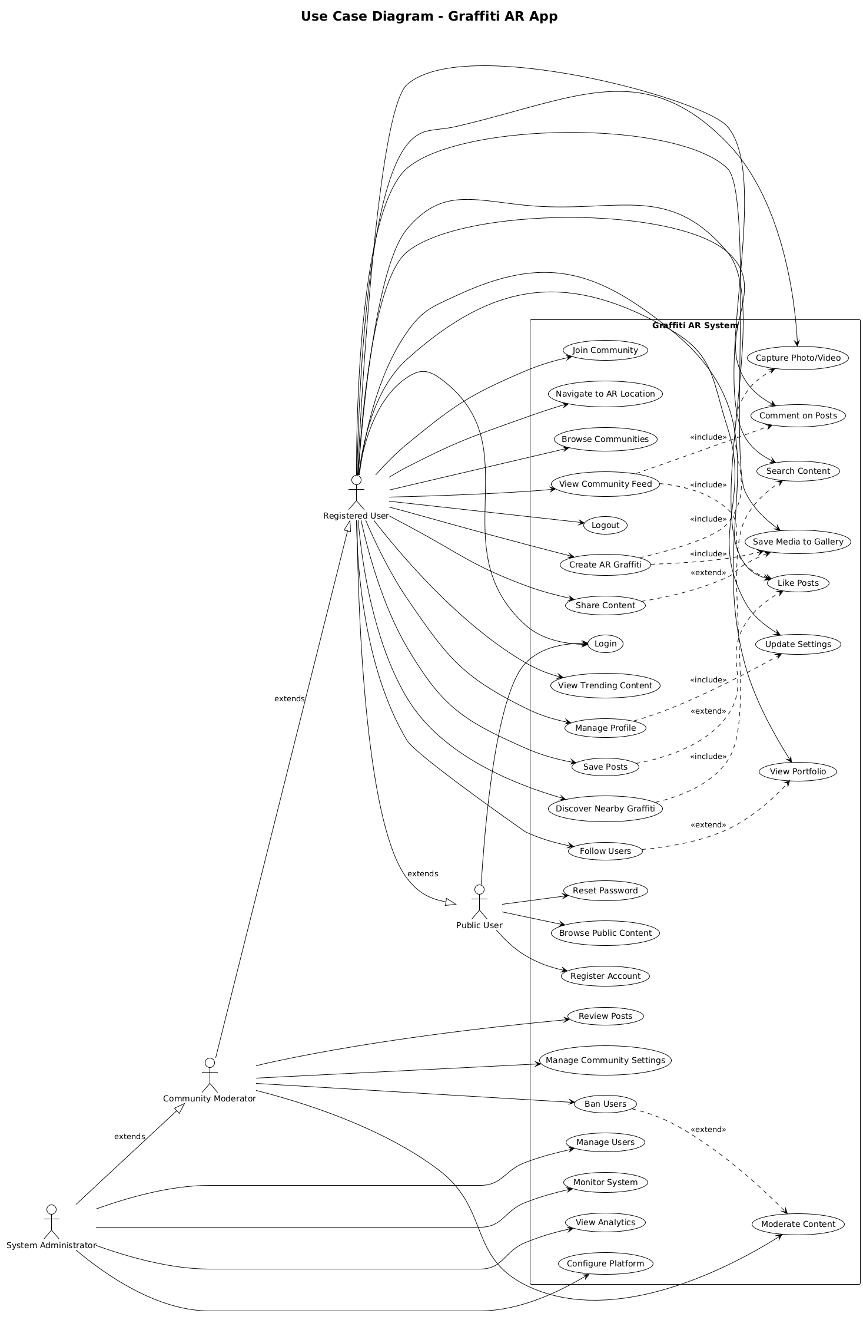
Figure 3.1 Use Case Diagram for Graffiniti

Use Case Description

Public User Use Cases

Browse Public Content
Primary Actor: Public User
Goal: View publicly available graffiti artwork and community content without creating an account.
Preconditions: The application is installed and launched.
Main Flow:
- The user opens the Graffiniti application.
- The system displays a public gallery featuring selected artwork.
- The user browses graffiti collections and trending content.
- The user views artwork details, creator information, and location data.
- The system restricts interaction to view-only mode.
Alternative Flow:
- If internet access is unavailable, cached public content is displayed.
Postconditions:
The user successfully views public content and may choose to register for full access.

Register Account
Primary Actor: Public User
Preconditions: A valid email address and internet connection are available.
Main Flow:
- The user selects the “Sign Up” option.
- The system displays the registration form.
- The user enters required details and accepts policies.
- The system validates the input and creates an account.
- A verification email is sent to the user.
- After verification, the system redirects the user to profile setup.
Alternative Flow:
- If the email already exists, the system suggests logging in instead.
Postconditions:
The account is created and the user becomes a registered user.

Login
Primary Actor: Public User/ Registered User
Goal: Access personalized features through authentication.
Main Flow:
- The user enters login credentials.
- The system verifies credentials and loads user data.
- The personalized home interface is displayed.
Postconditions:
The user is authenticated and granted full access.

Reset Password
Primary Actor: Public User
Goal: Reset Password
Main Flow:
- The user selects “Forgot Password”.
- The system sends a reset link to the registered email.
- The user sets a new password.
Postconditions:
Account access is restored successfully.

Registered User Use Cases

Create AR Graffiti
Primary Actor: Public User
Goal: Create location based digital graffiti using AR tools
Preconditions: User is logged in, ARCore supported device, permissions granted.
Main Flow:
- The user opens the camera and selects AR Graffiti mode.
- The system initializes ARCore and environmental tracking.
- The user selects tools and customizes properties.
- Artwork is created using touch gestures.
- The system renders content in real time.
- The artwork is saved with location metadata.
Alternative Flow:
If ARCore fails, the system displays an error and suggests alternatives.
Postconditions:
The AR artwork is saved to the user’s portfolio.

Capture Photo or Video
Primary Actor: Registered User
Goal: Capture media using the built-in camera.
Main Flow:
- The user opens the camera interface.
- A capture mode is selected.
- Media is captured and previewed.
- The user saves or retakes the content.
Postconditions:
Media is saved to the device and user account.

Join Community
Primary Actor: Registered User
Goal: Become a member of an art community.
Main Flow:
- The user browses available communities.
- Community details are reviewed.
- The user joins the community.
- Access to the community feed is granted.
Postconditions:
The user becomes an active community member.

Like Posts
Primary Actor: Registered User
Goal: Express appreciation for content.
Main Flow:
- The user taps the like icon on a post.
- The system records the interaction.
- The content creator is notified.
Postconditions:
The like is stored and engagement metrics are updated.

Manage Profile
Primary Actor: Registered User
Goal: Update personal information and preferences.
Main Flow:
- The user opens the profile section.
- Profile details are edited and saved.
- The system confirms the update.
Postconditions:
Profile information is updated across the platform.

Community Moderator Use Cases

Review Posts
Primary Actor: Community Moderator
Goal: Ensure community content follows guidelines.
Main Flow:
- The moderator reviews submitted posts.
- Posts are approved or rejected with feedback.
- The creator is notified of the decision.
Postconditions:
Community standards are maintained.

Ban Users
Primary Actor: Community Moderator
Goal: Remove disruptive users from the community.
Main Flow:
- The moderator reviews violations.
- A ban decision is applied.
- The system enforces restrictions and logs the action.
Postconditions:
Community quality is preserved.

System Administrator Use Cases

Manage Users
Primary Actor: System Administrator
Goal: Oversee platform-wide user management.
Main Flow:
- Administrator reviews user accounts.
- Appropriate actions are taken when necessary.
- All actions are logged for audit purposes.

Monitor System
Primary Actor: System Administrator
Goal: Ensure system stability and performance.
Main Flow:
- System metrics and logs are monitored.
- Issues are identified and resolved proactively.

View Analytics
Primary Actor: System Administrator
Goal: Analyze platform usage and engagement trends.
Main Flow:
- Administrator reviews dashboards and reports.
- Insights are generated to guide improvements.

Modules of Developed System

User Authentication Module

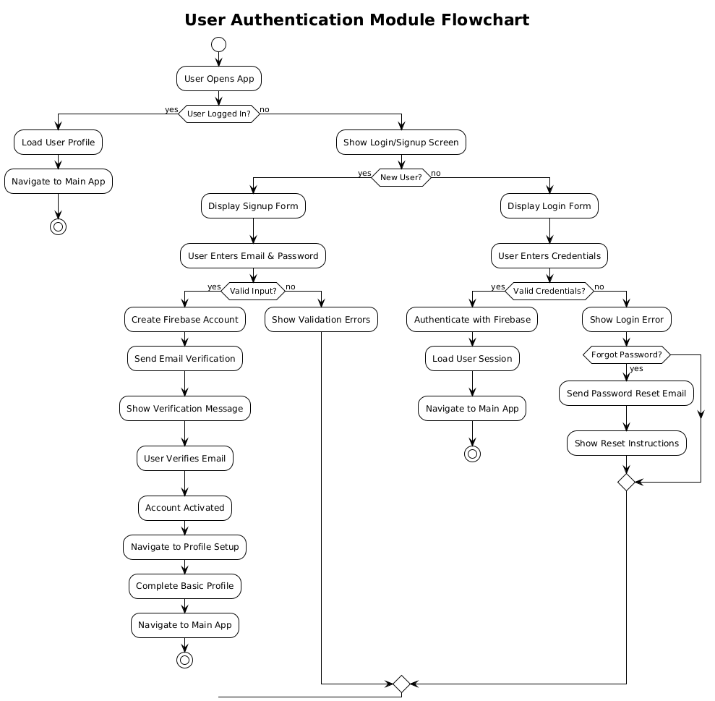
Figure 3.2 User Authentication Module FlowChart

Camera System Module
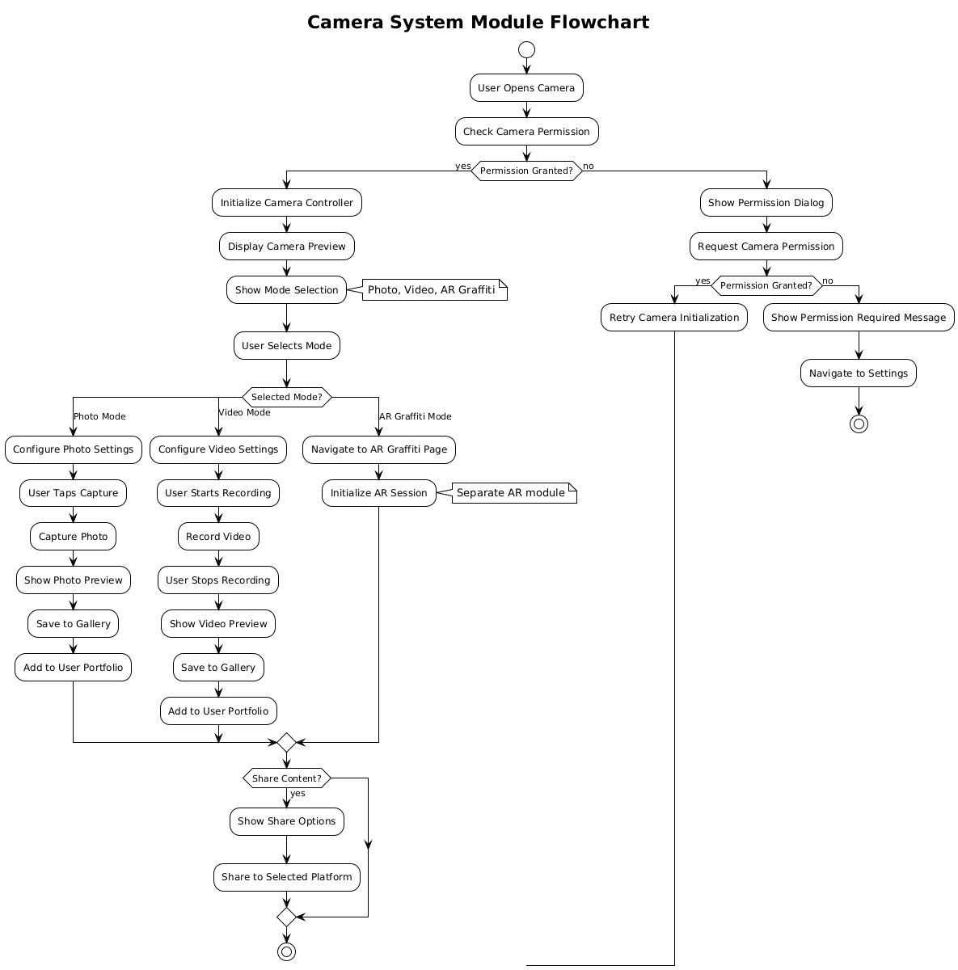
Figure 3.3Camera System Module FlowChart

Communities Module

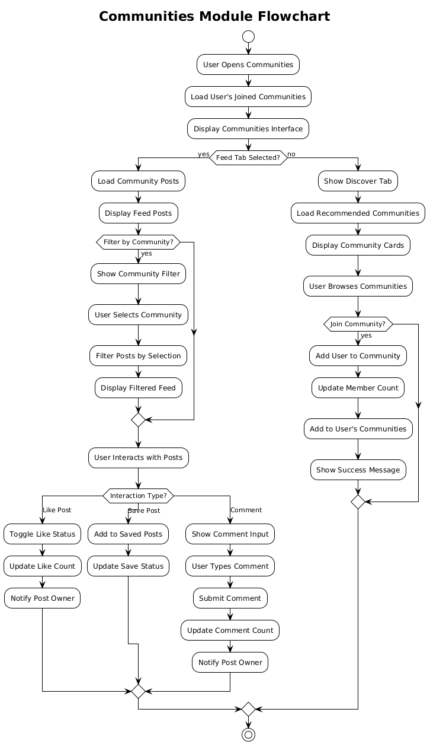
Figure 3.4 Communities Module FlowChart

Profile Management Module

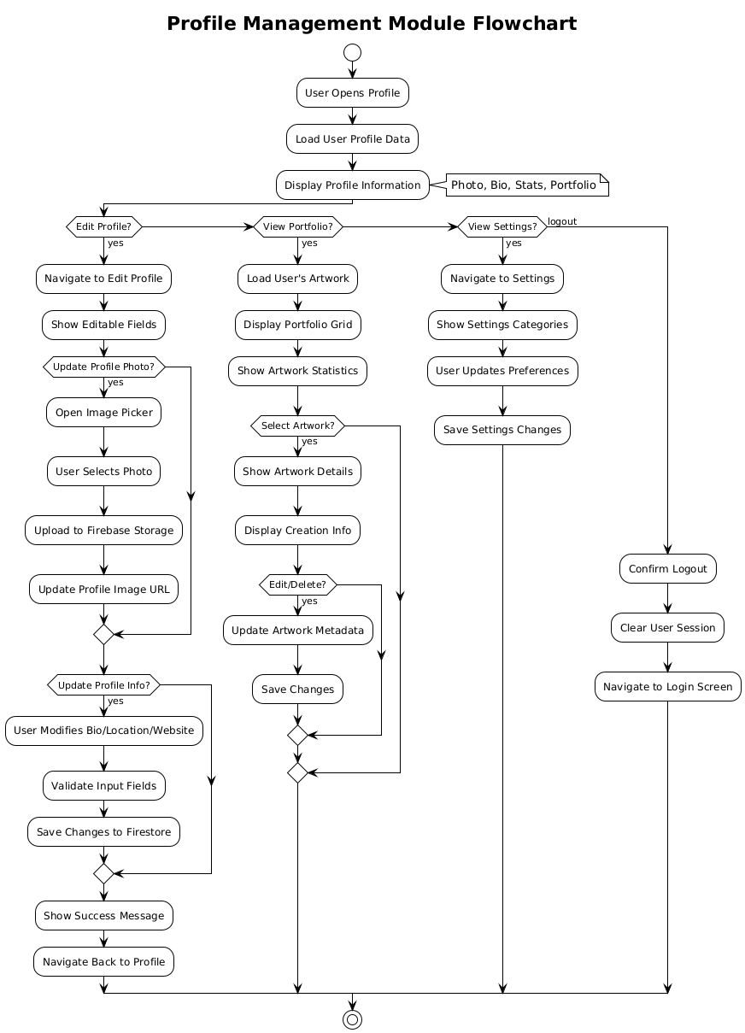
Figure 3.5 Profile Management Module FlowChart

Media Management Module

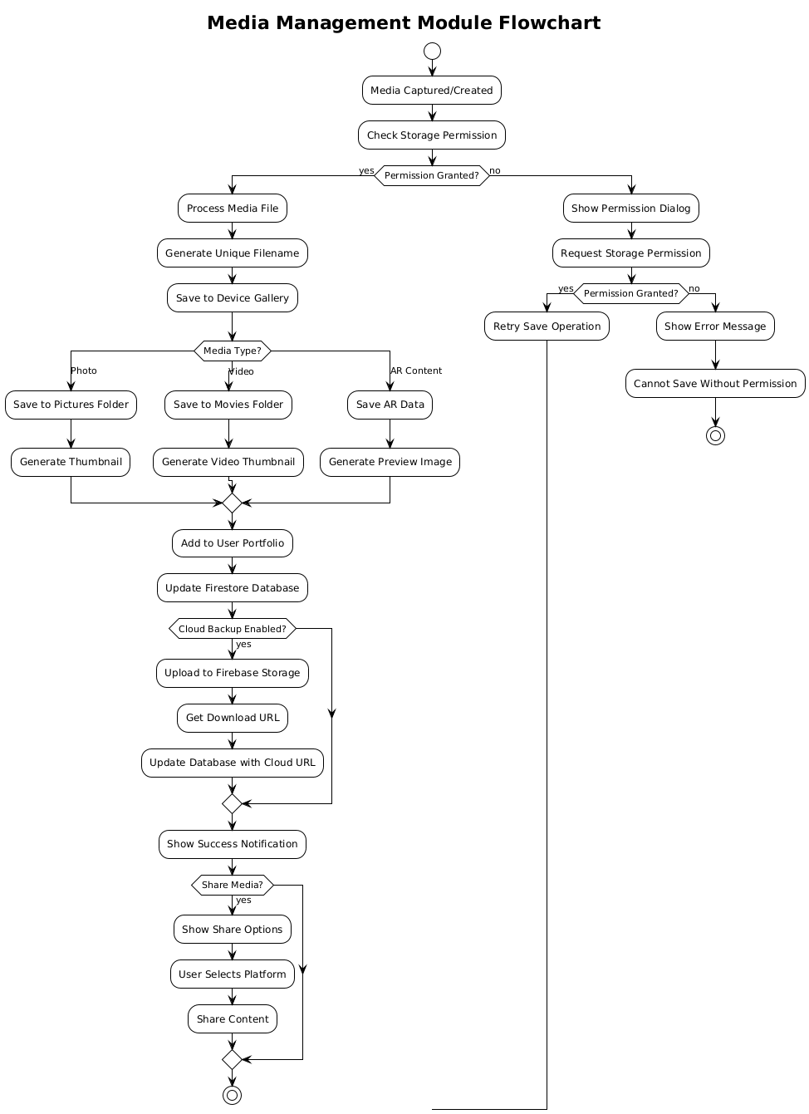
Figure 3.6 Media Management Module FlowChart

AR Graffiti Creation Module (UI Implementation)

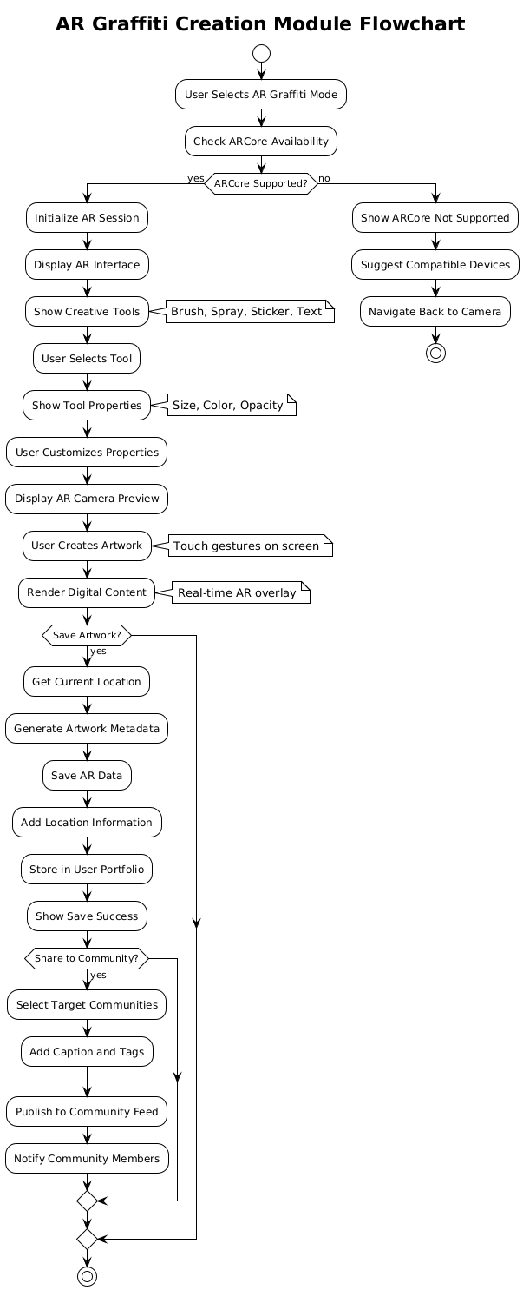
Figure 3.7 AR Graffiti Creation Module (UI Implementation) FlowChart

Chapter 4

System Modelling

Introduction
This chapter includes the design of the system, detailing both its static and dynamic aspects. The design phase translates the requirements defined in the previous chapter into a clear blueprint that guides development and implementation.
It includes various Unified Modelling Language diagrams to provide a view of system structure, behaviour, and interactions. The chapter also covers the perspectives of different user roles including public user and administrators, showing how the system supports their interactions and responsibilitiess

(4+1) View Model
The architectural design of the system is structured using the 4+1 view model. This approach helps to visualize how different components of the system interact and work together. It provides a clear picture of the system’s structure and improves communication between stakeholders and developers. The model is divided into four main views, namely Logical View, Process View, Development View, and Physical View, along with one additional scenario-based view.
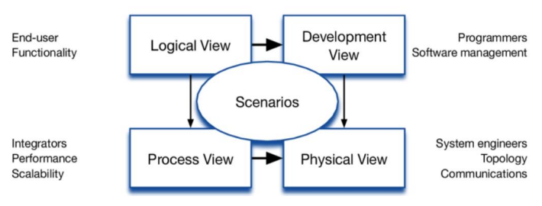
Figure 4.1 View Model Diagram

Logical View
The logical view focuses on the structure and functionality of the system and shows how the system is designed to satisfy the requirements. For this purpose, followings are used:

Class Diagram
The Class diagram shows the static structure of the system. It shows classes, their attributes, methods, and relationships between them. It helps to understand the blueprint of the system and tells how objects interact with each other.
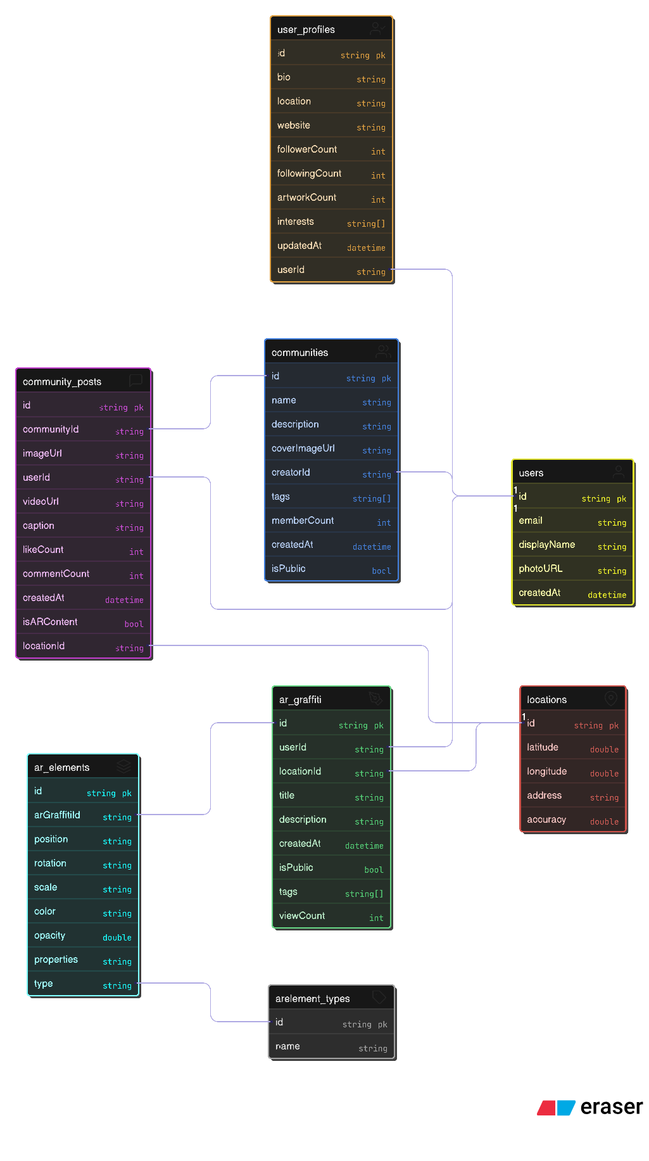
Figure 4.2 Class Diagram of Graffinit

Process View
The Process View shows the dynamic behavior of the system. It focuses on the flow of control and tells how the interaction between components occurs. Following diagram are included in the process view:
- Activity Diagram
- Sequence Diagram
- Entity Relational Diagram

Activity Diagram
It represents the workflow within the system, illustrating how each activity leads to another activity. The diagram shows the sequence of steps or activities from the perspective of four main roles. For public user, registered user, community moderator and for the system Admin.

Public User Activity Diagram
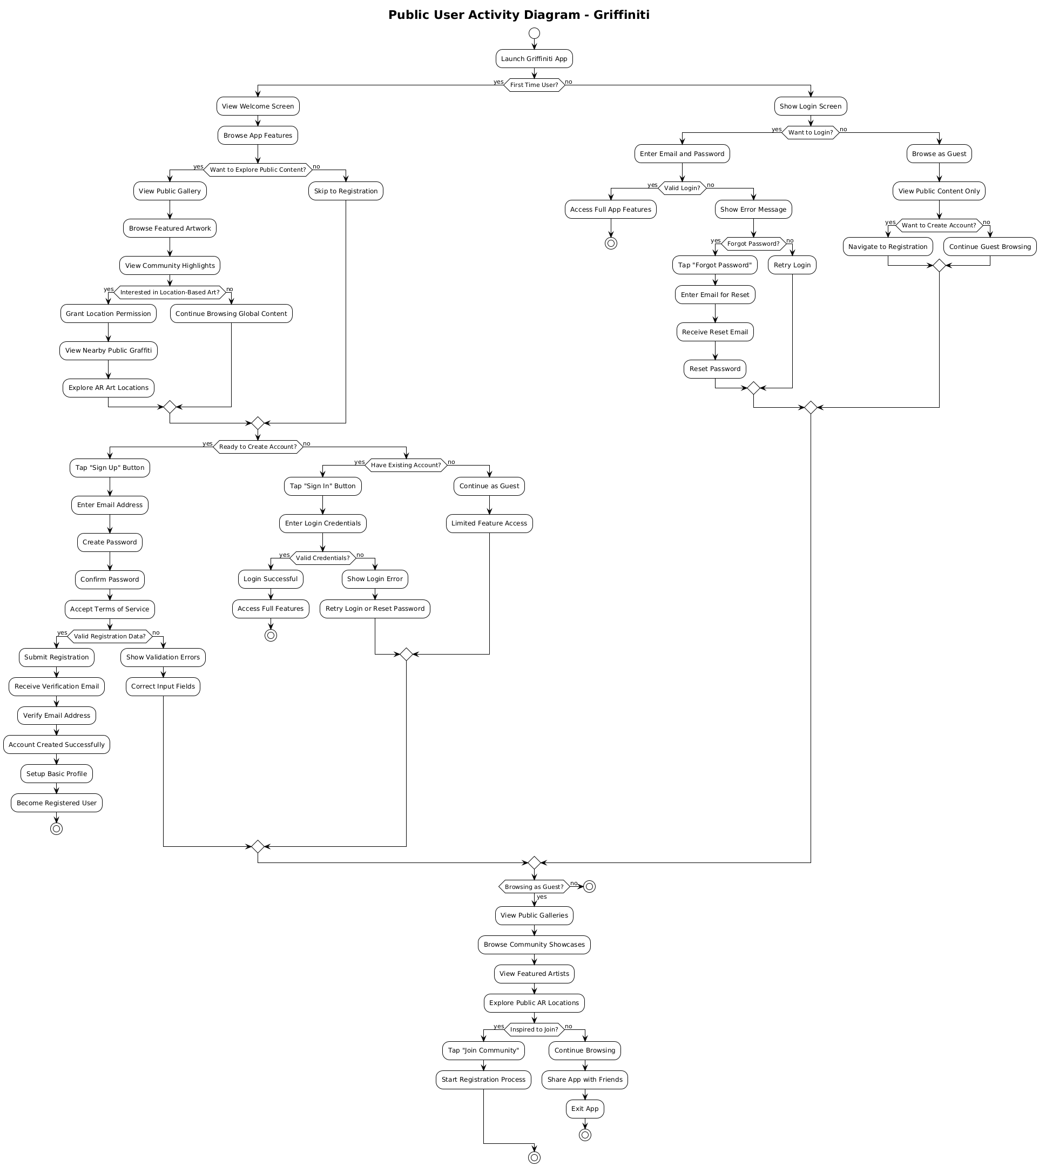
Figure 4.3Public User Activity Diagram

Registered User Activity Diagram
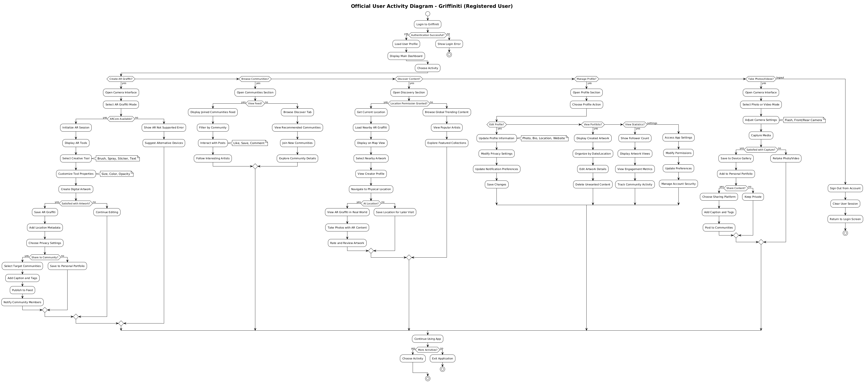
Figure 4.4 Registered User Activity Diagram

Community Moderator Activity Diagram
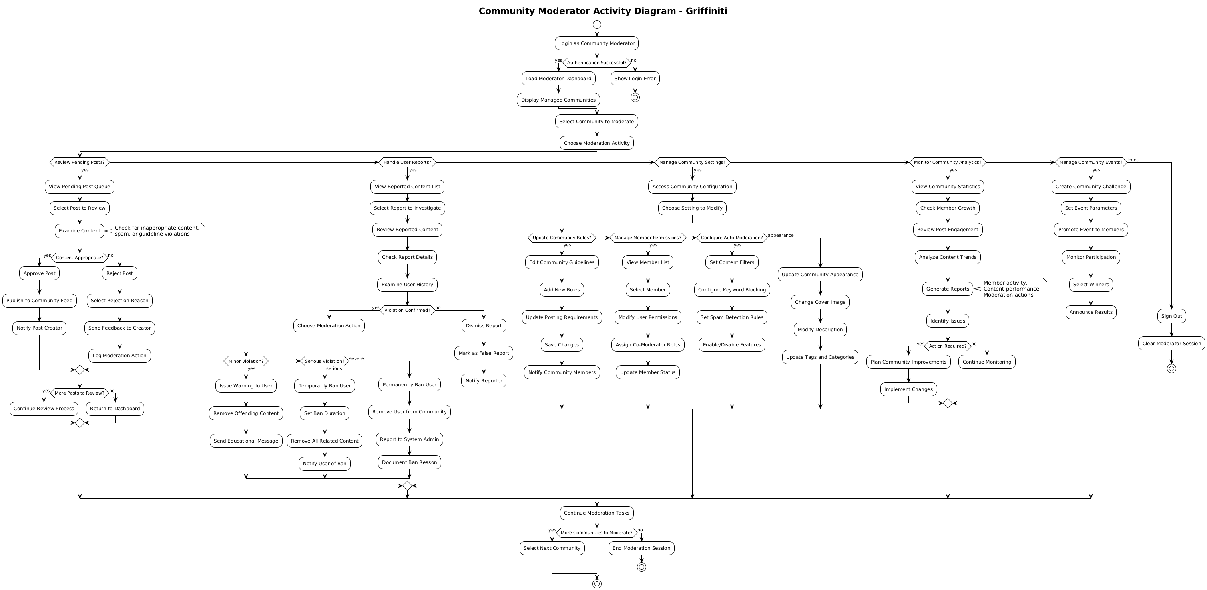
Figure 4.5 Community Moderator Activity Diagram

System Administrator Activity Diagram
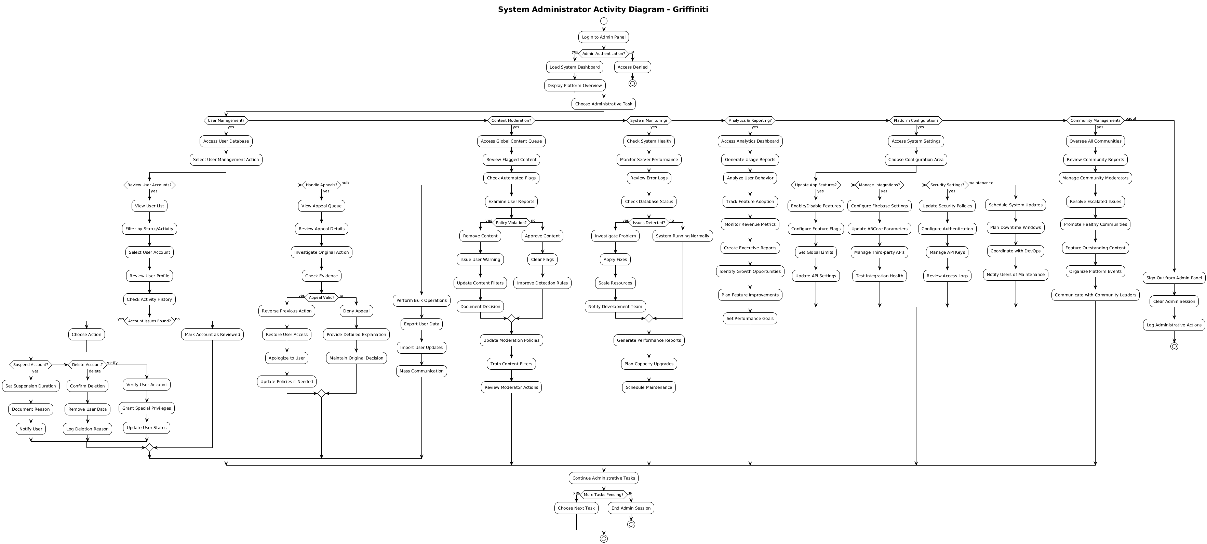
Figure 4.6 System Admin Activity Diagram

Sequence Diagrams
The Sequence Diagram shows the interaction between the components or objects over time. The vertical axis represents time, while the horizontal axis shows the components and the messages exchanged between them. It also indicates how each component participates in each interaction. The diagram helps in understanding how components collaborate to fulfill a use case. Following are the sequence diagrams for the main features of the system.

Registration Sequence Diagram
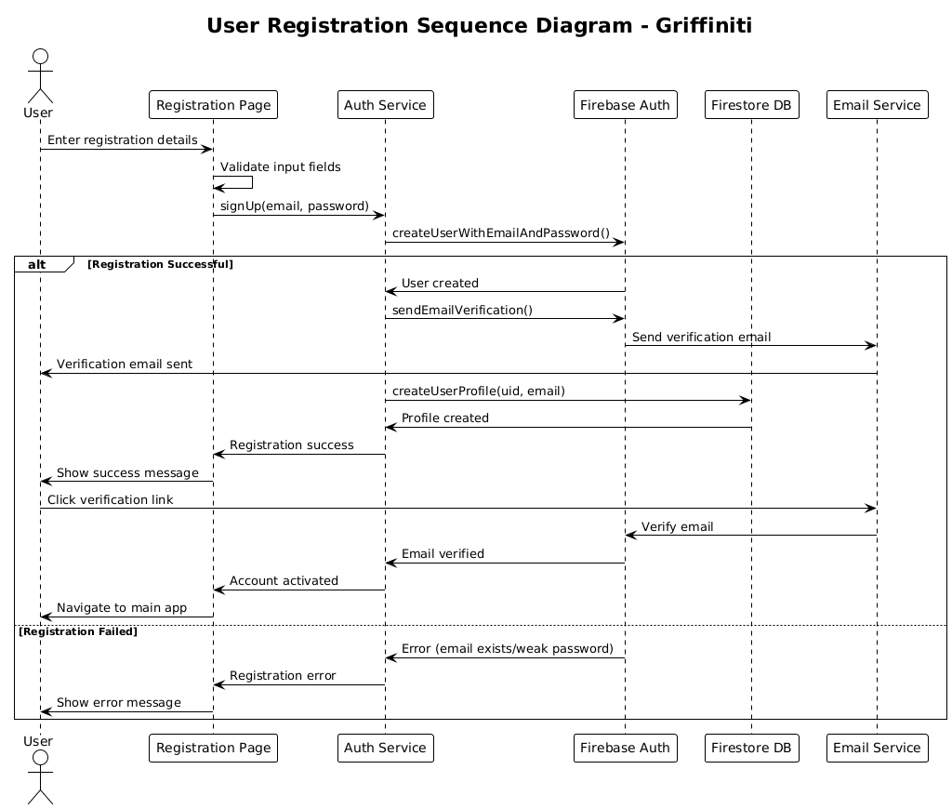
Figure 4.7 Registration Sequence Diagram

User Login Sequence Diagram
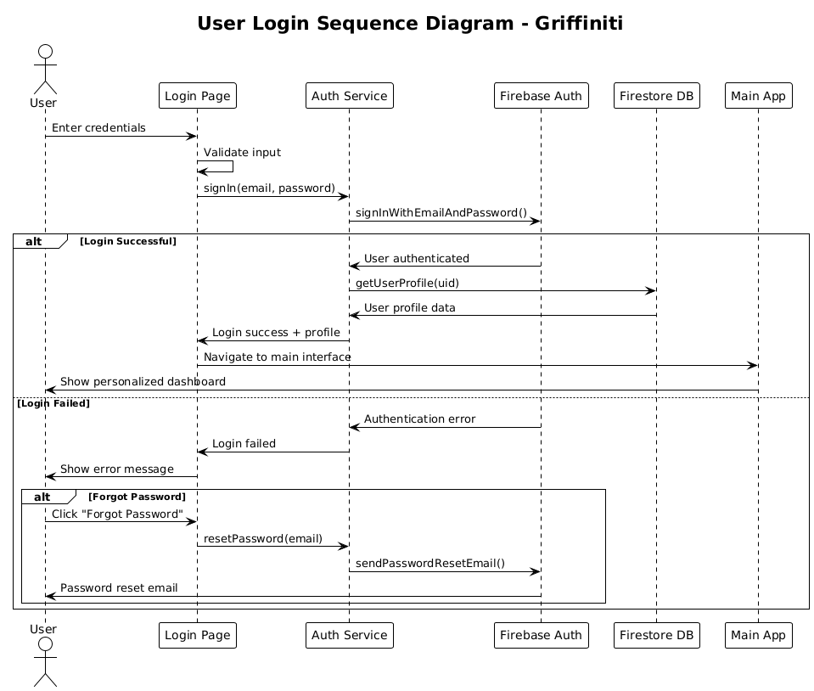
Figure 4.8 User Login Sequence Diagram

AR Graffiti Creation Sequence Diagram
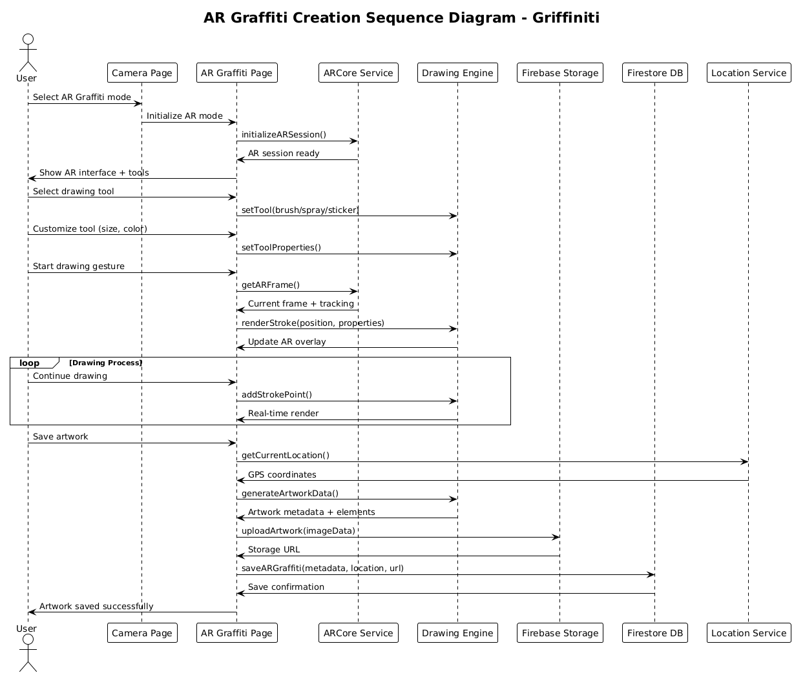
Figure 4.9 AR Graffiti Creation Sequence Diagram

Camera Operations Sequence Diagram
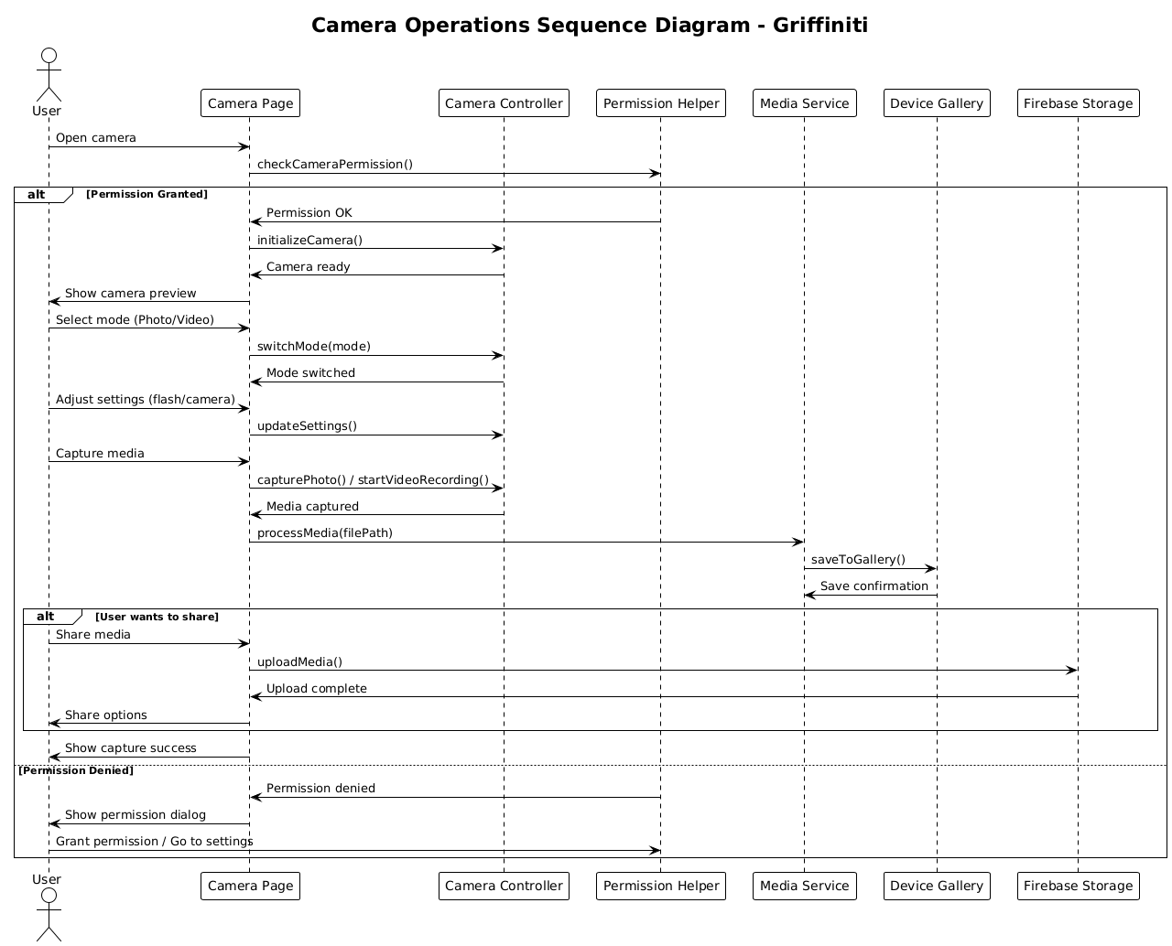
Figure 4.10 Camera Operations Sequence Diagram

Community Interaction Sequence Diagram
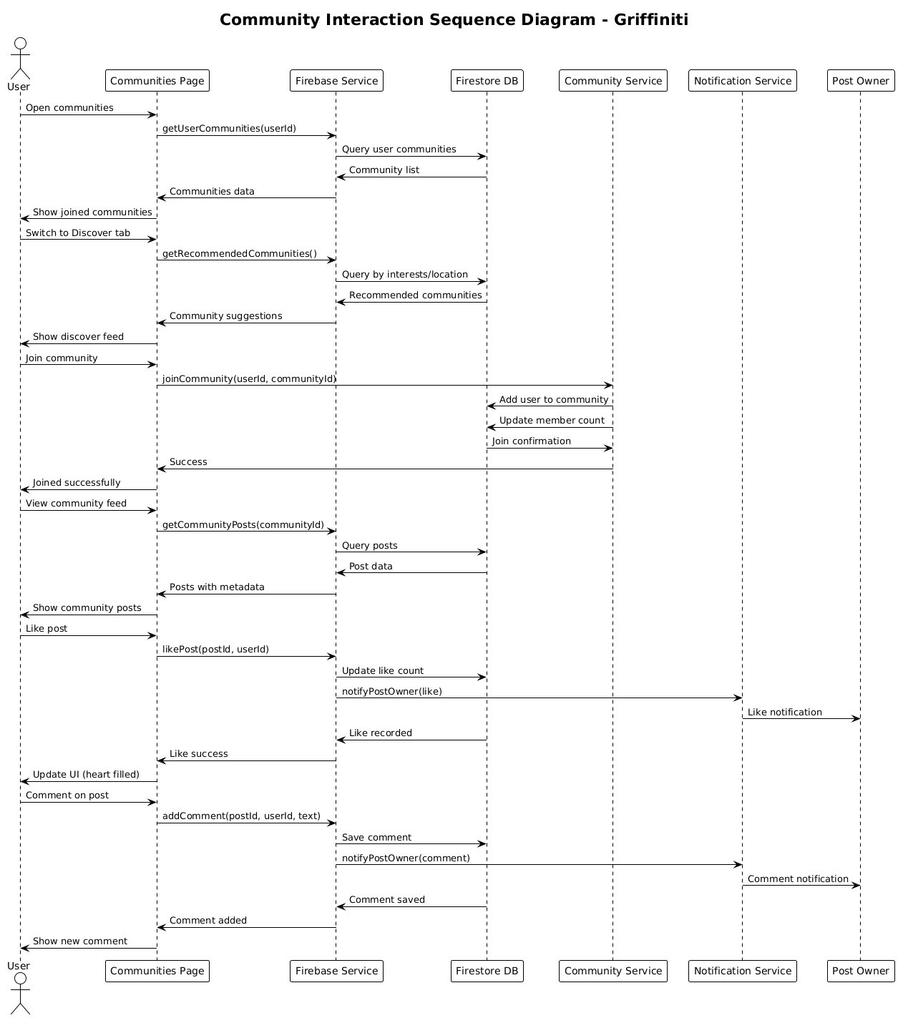
Figure 4.11 Community Interaction Sequence Diagram

Content Discovery Sequence Diagram

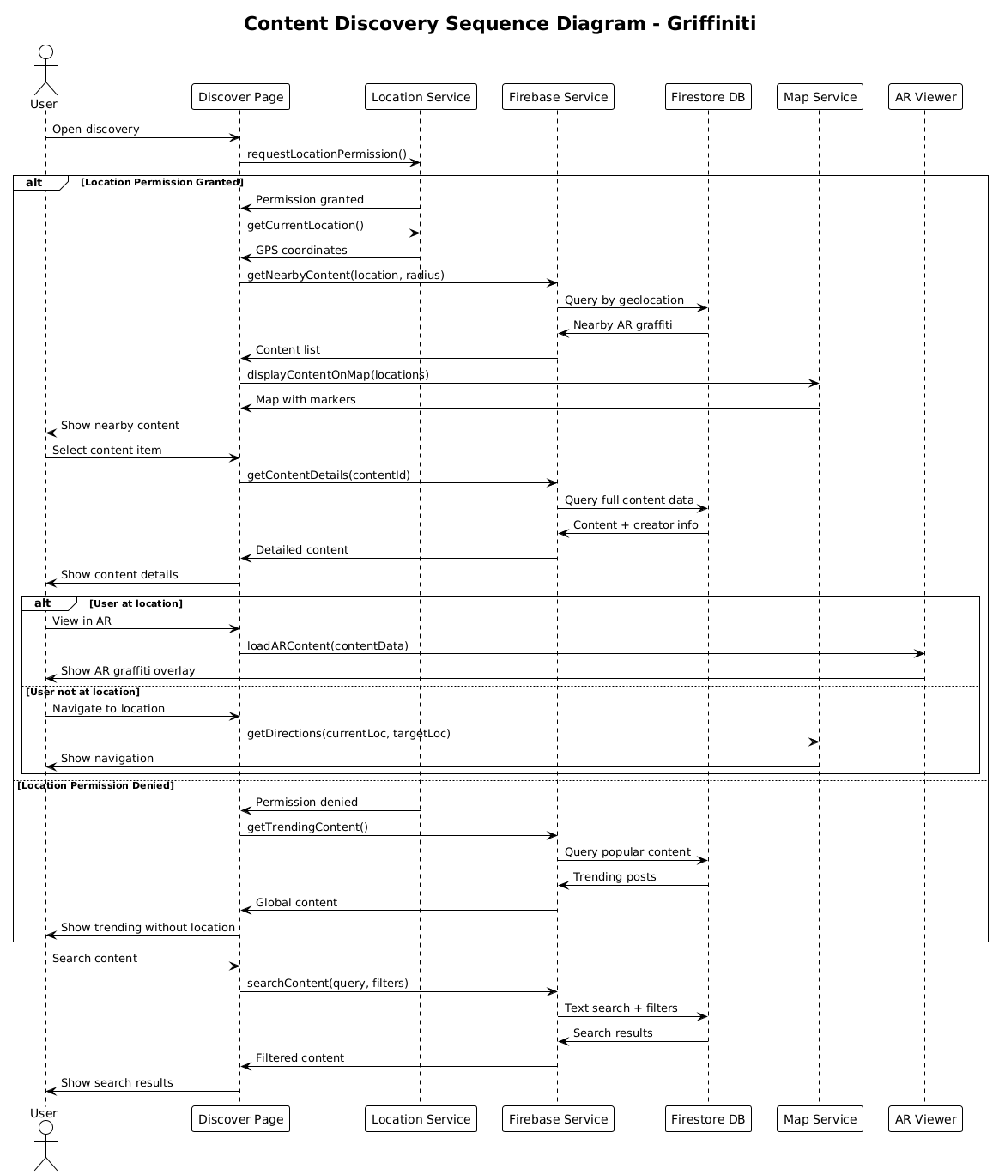
Figure 4.12 Content Discovery Sequence Diagram

Media Saving Sequence Diagram
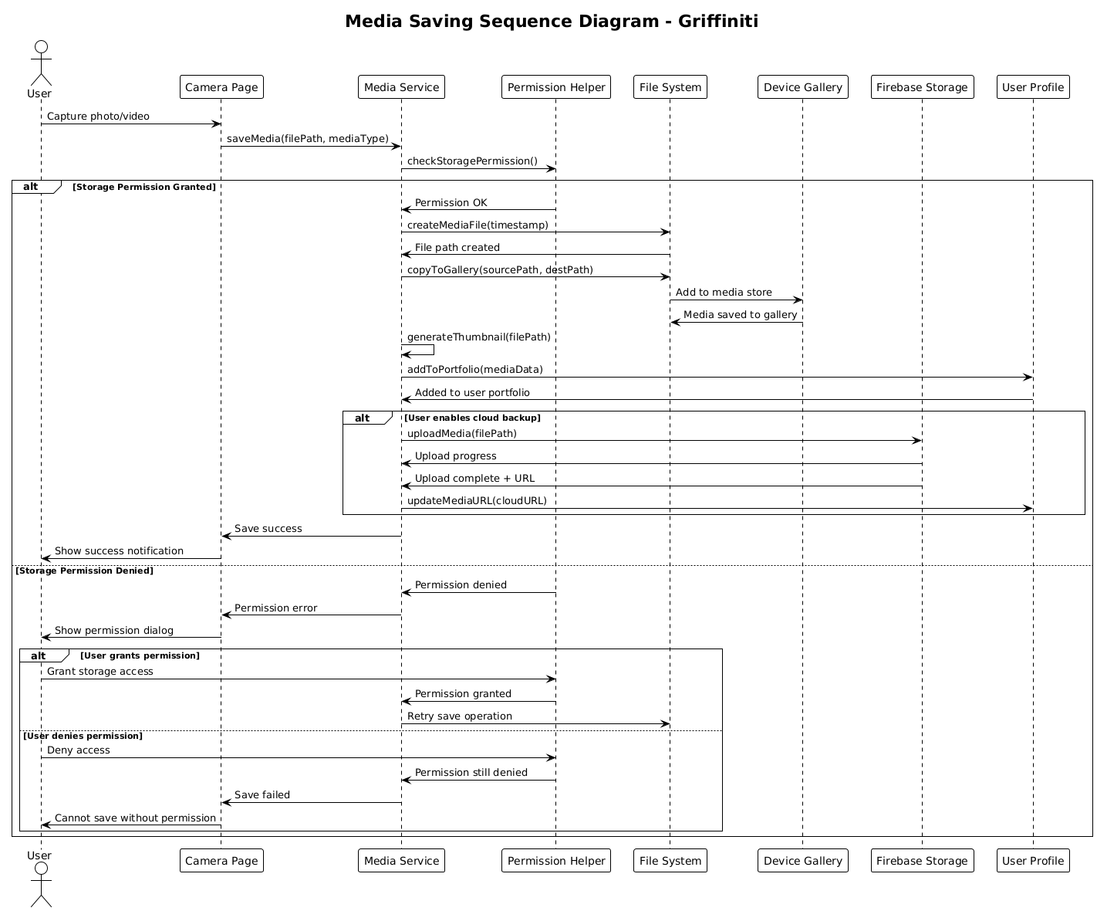
Figure 4.13 Media Saving Sequence Diagram

Profile Management Sequence Diagram
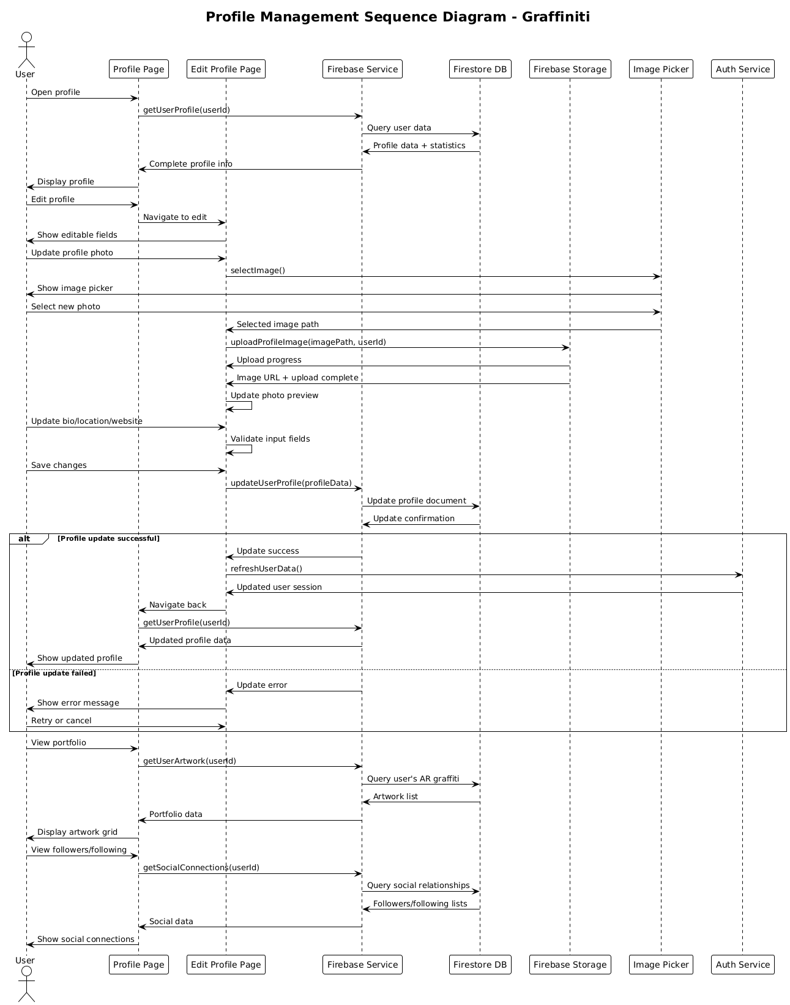
Figure 4.14 Profile Management Sequence Diagram

Location Services Sequence Diagram
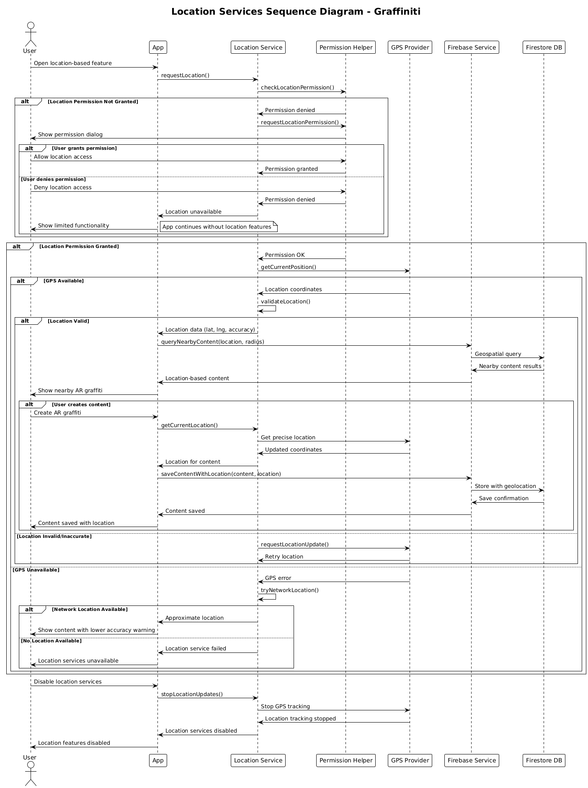
Figure 4.15 Location Services Sequence Diagram

Social Features Sequence Diagram
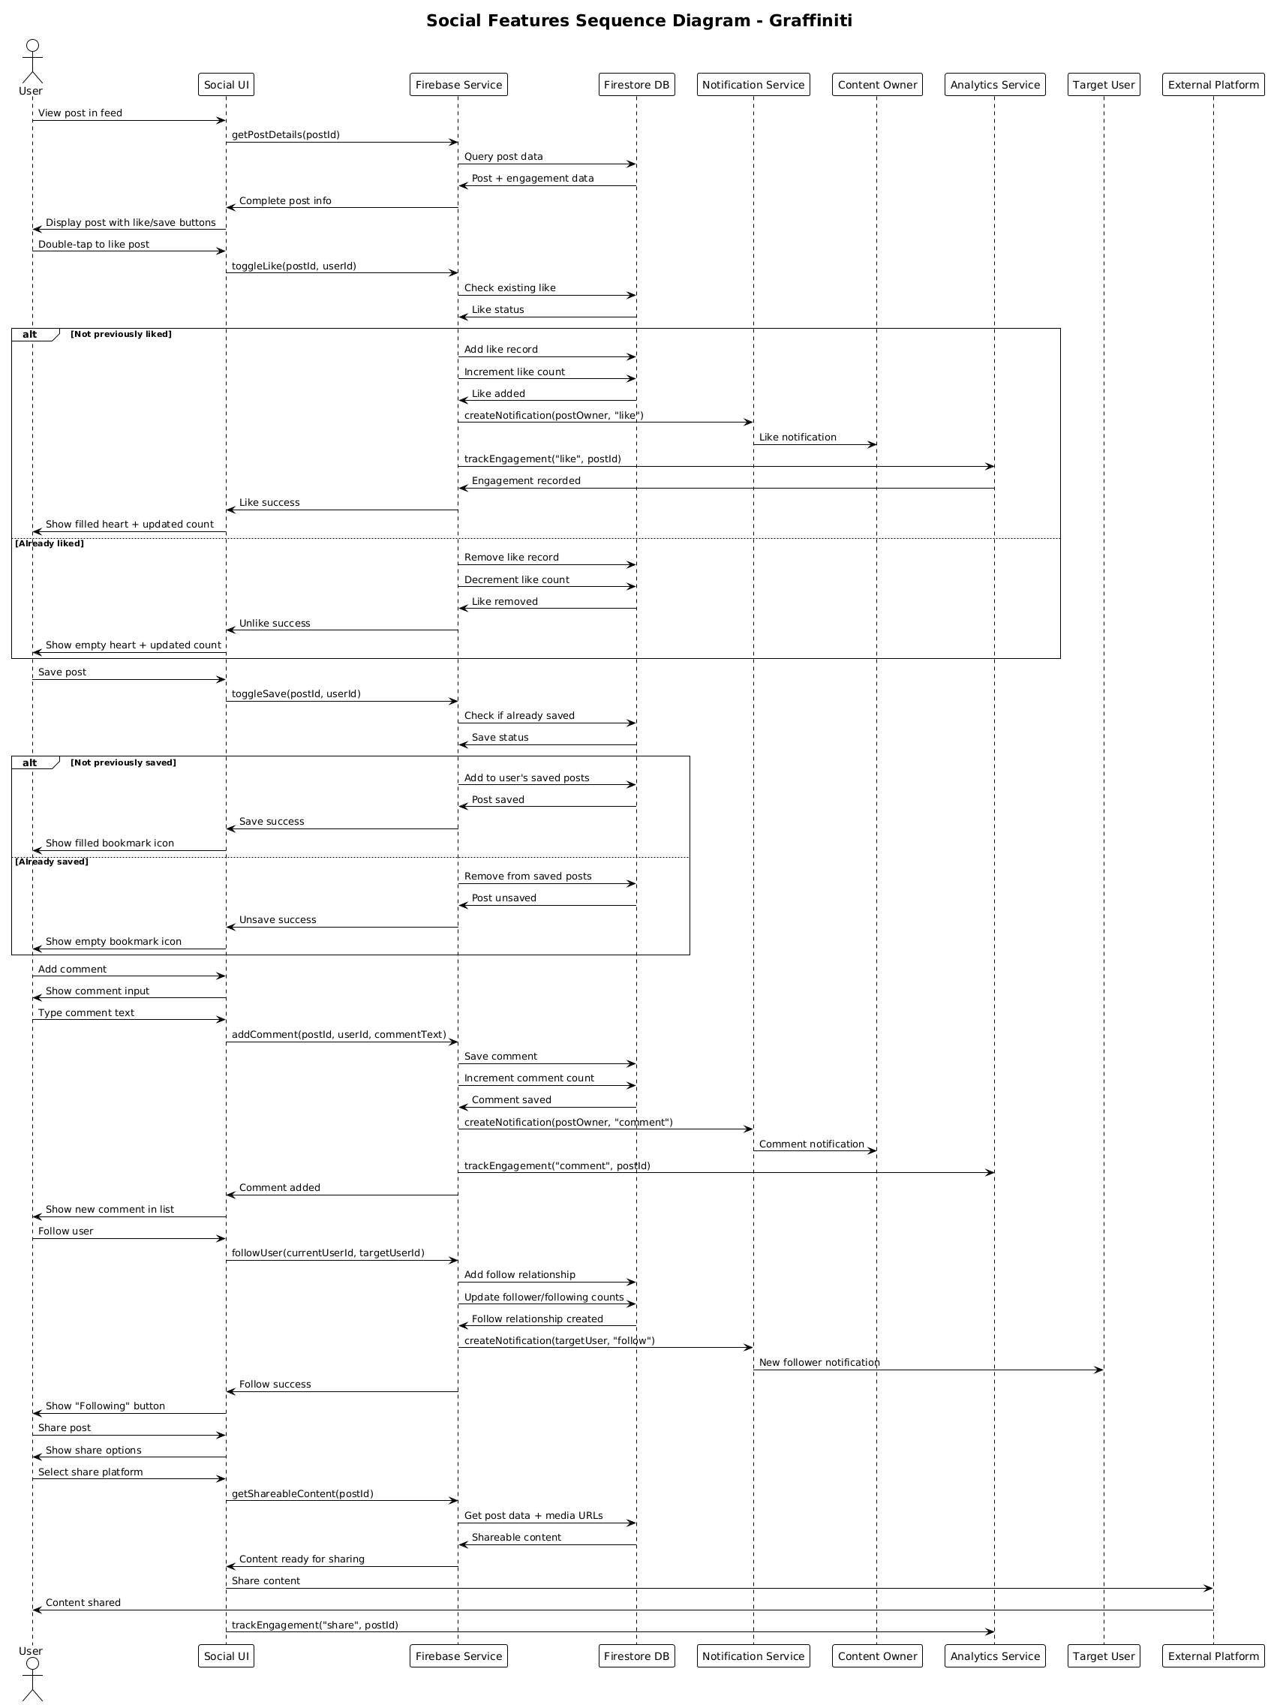Figure 4.16 Social Features Sequence Diagram

Firebase Integration Sequence Diagram
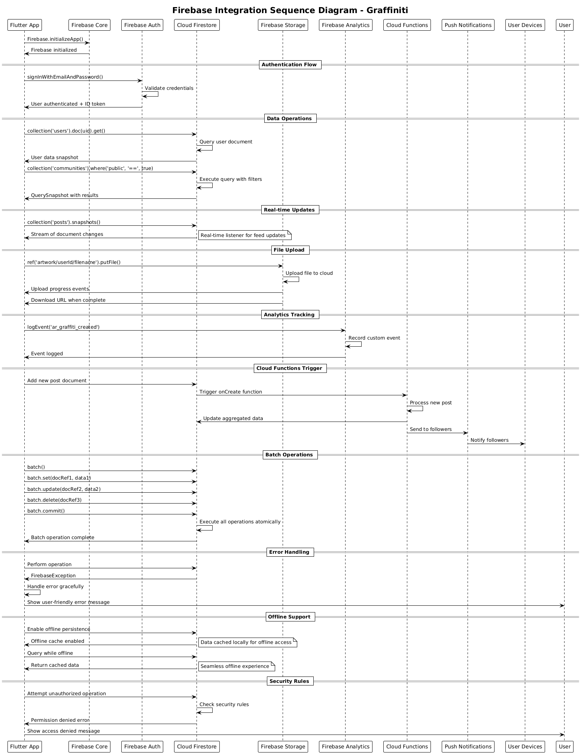
Figure 4.17 Firebase Integration Sequence Diagram

ERD
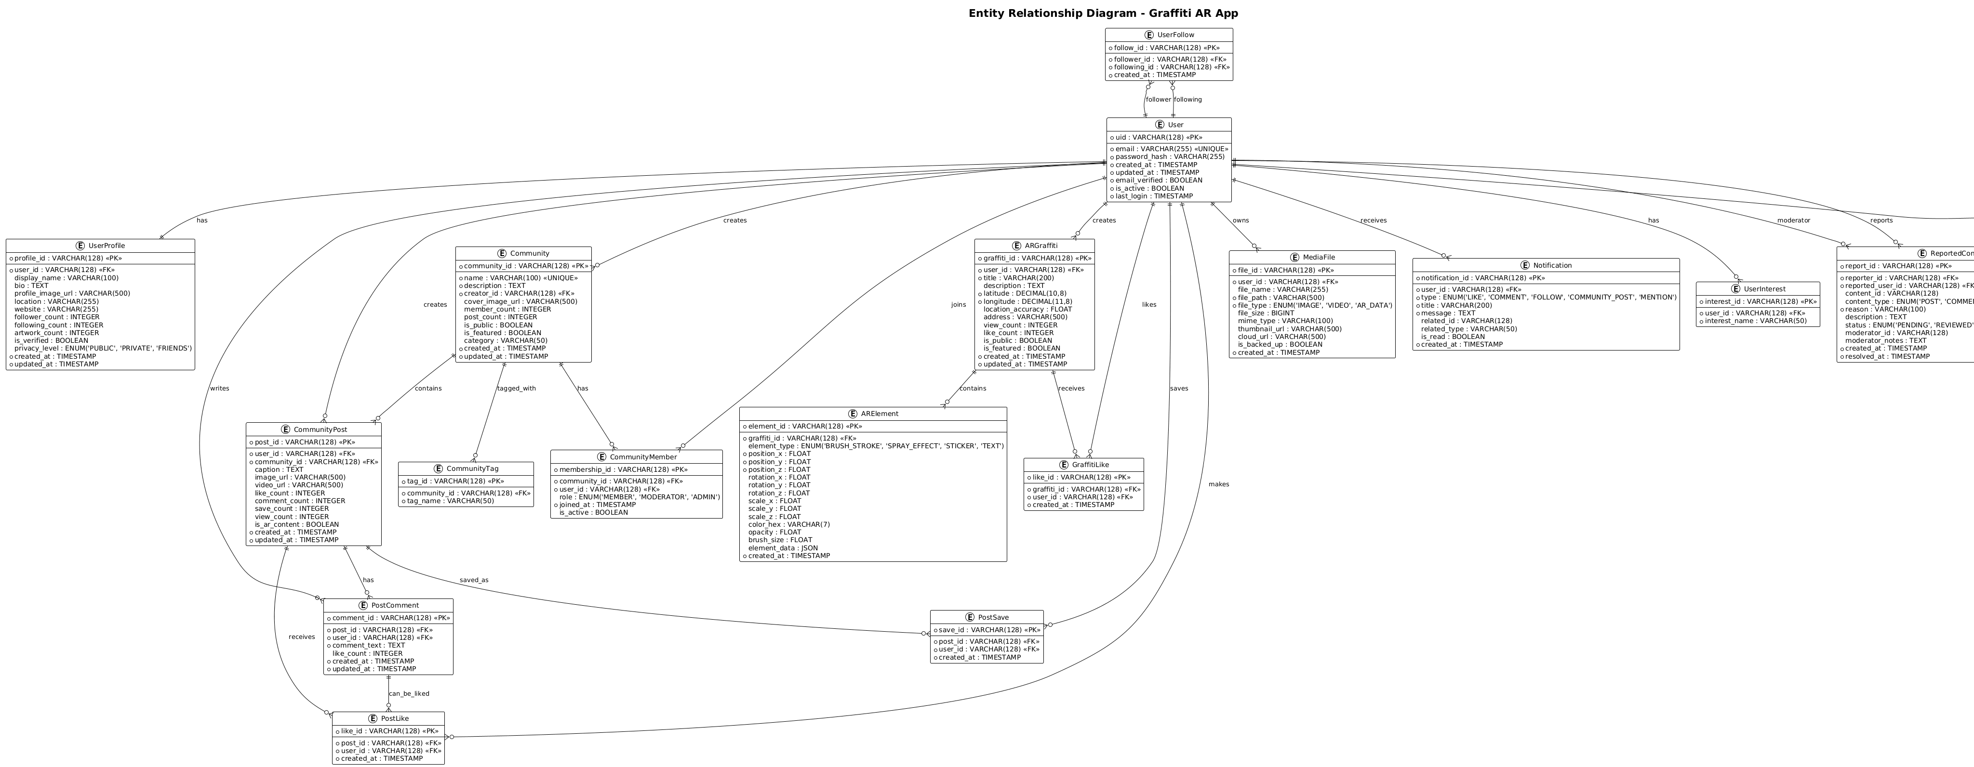
Figure 4.18 ERD Diagram

Development View
The development view focuses on the organization of the software module and how the system is structured for development and maintenance.

Package Diagram
The Package diagram groups related classes into packages or modules, showing dependencies between them. It helps to manage complexity by hiding extra details and organizing the system into logical modules, which helps in making development and maintenance easier.
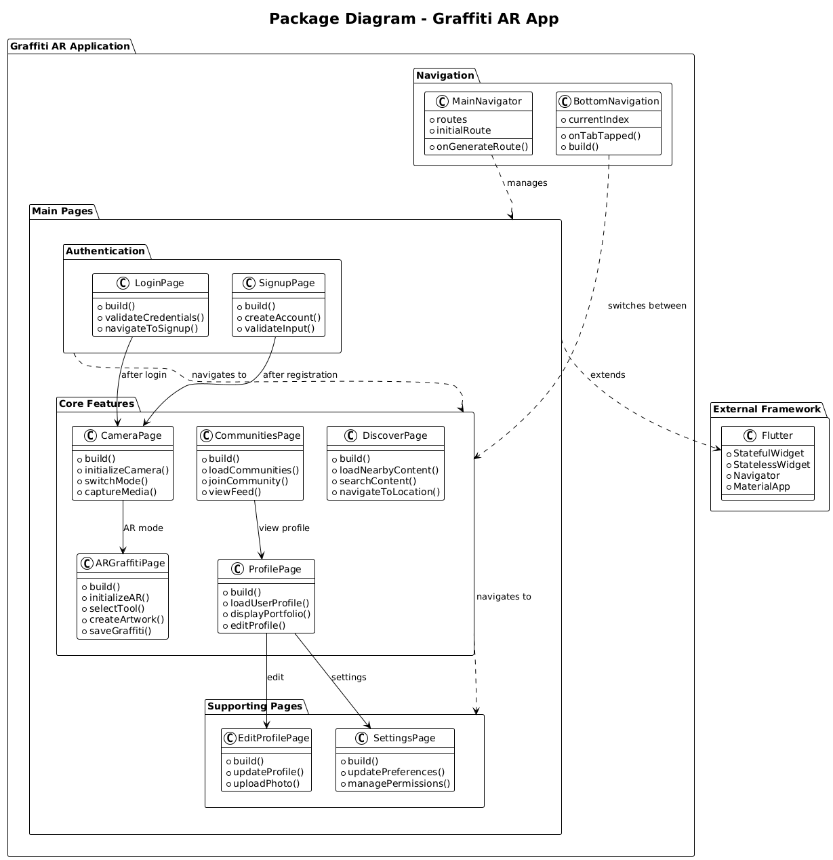
Figure 4.19 Package Diagram

Physical View
The Physical View focuses on hardware and system infrastructure. It shows how each software component is mapped to a hardware node and how the system will be physically deployed.

Deployment Diagram
The Deployment Diagram represents the physical architecture of the system by showing servers, devices, nodes, and the deployment of software artifacts. It helps to understand the network configuration, hardware requirements, and system scalability. In other words, it helps stakeholders visualize and analyze the deployment layout easily and effectively
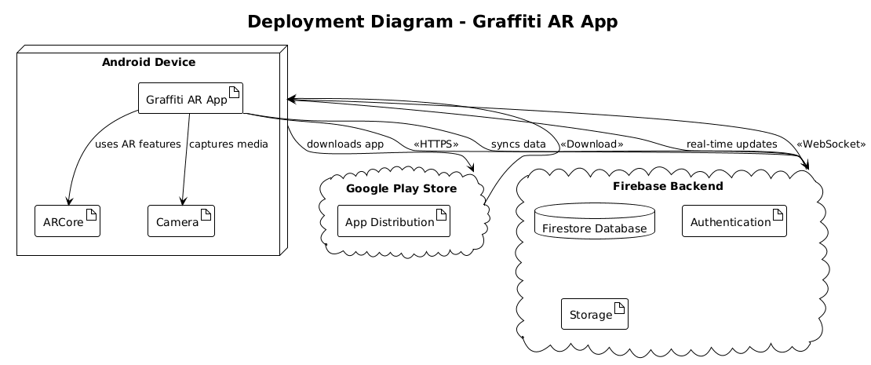
Figure 4.20 Deployment Diagram

System Prototype

Login Page
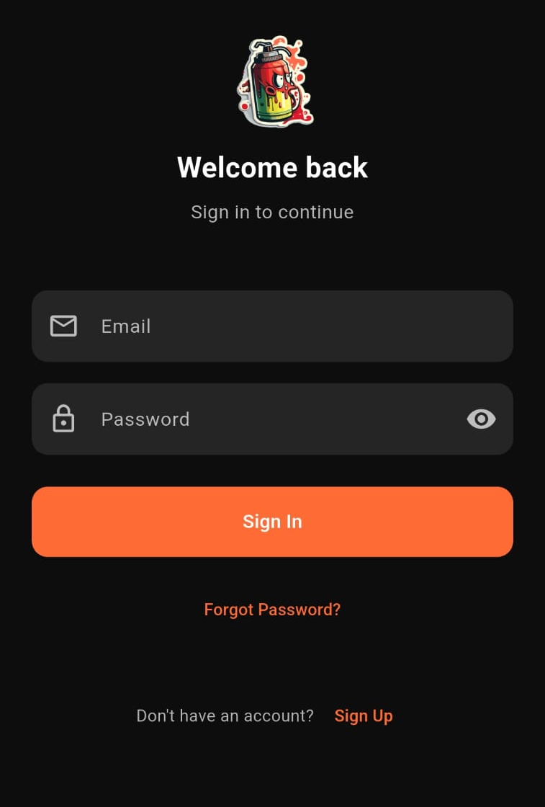
Figure 4.21 Login Page Graffiniti

Sign up Page
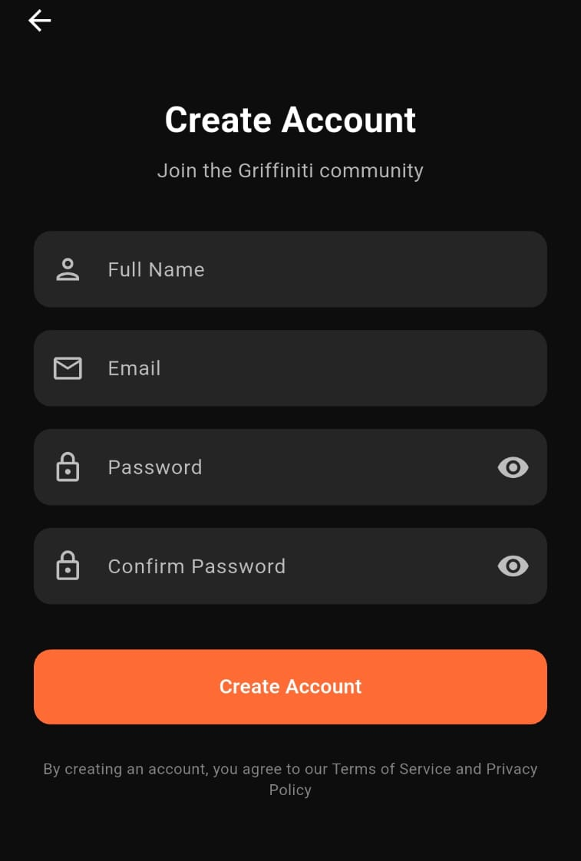
Figure 4.22 Sign Up Page

Discover Page
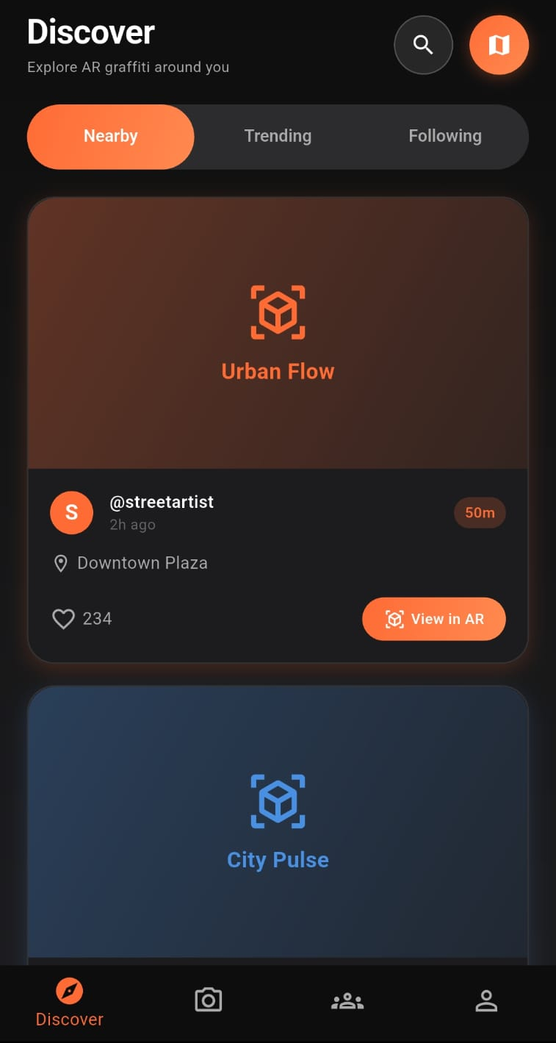
Figure 4.23 Discover Page

Communities Page
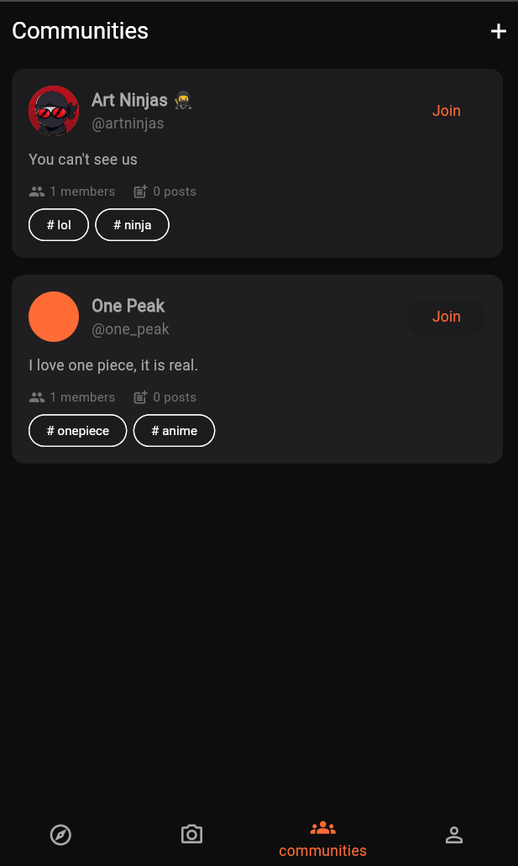
Figure 4.24 Communities Page

Profile Page
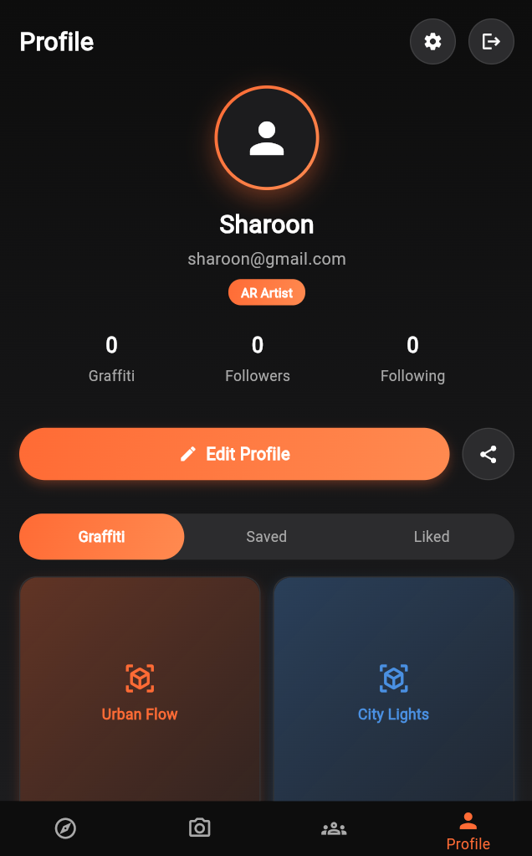
Figure 4.25 Profile Page

Edit Profile Page
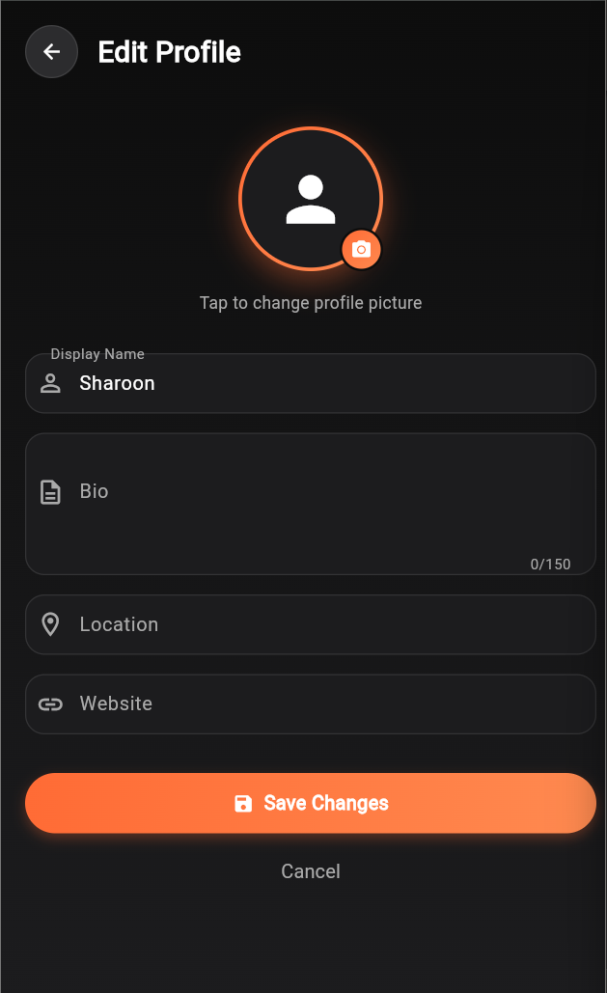
Figure 4.26 Edit Profile Page

Community Page
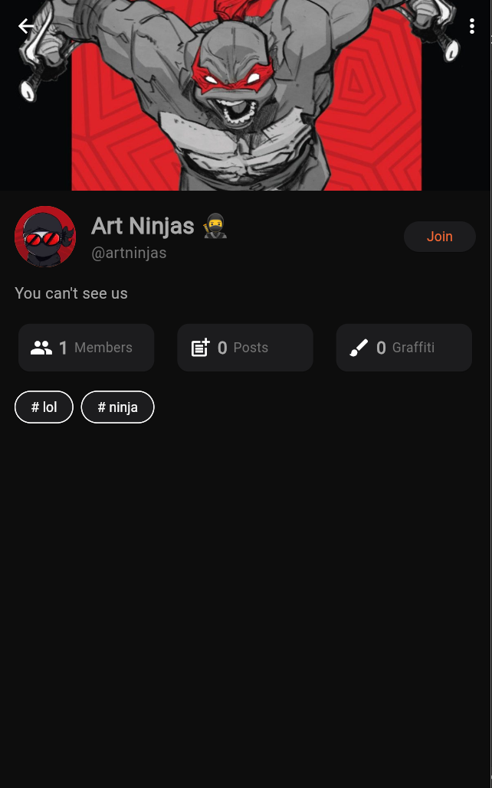
Figure 4.27 Community Page

Community Settings
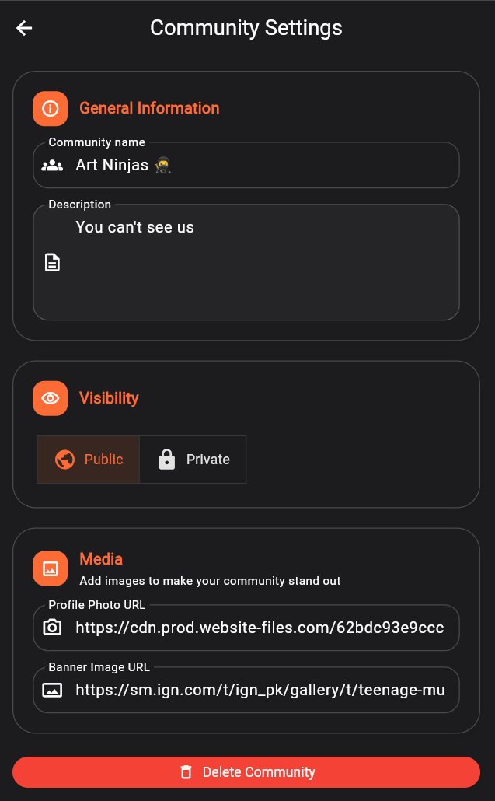
Figure 4.28 Community Settings

